Algorithms and Data Structures (ALG)

Indhold

Concepts 2

Computational Problem 2

Algorithm and Pseudocode 2

Worst-case and best-case analysis 2

Asymptotic Notation (big-O, big-Omega, and big-Theta) 3

Properties of Asymptotic Notations : 4

Proving the correctness of an algorithm (using e.g., induction or loop invariants) 6

Solving Recurrences (using, substitution, recursion-tree, and Master methods) 7

max/min-heap property 11

Hash functions and their properties 13

Binary search tree property 15

Red-black-tree property 15

Optimal Substructure Property 17

Graph of dependencies 18

Graphs, cycles on graphs, negative cycles, directed acyclic graphs 19

Topological ordering on an acyclic graph 21

shortest paths problems on graphs and weighted graphs 23

Rod Cutting problem 23

Algorithms 29

Insertion Sort 29

Merge Sort 30

Heapsort 32

Quicksort 36

Counting Sort 37

Radix Sort 37

Breadth-First Search 38

Depth-first Search 41

Topological Sorting 43

Computing Strongly Connected Components 45

Bellman-Ford Algorithm 47

Dijkstra’s algorithm 50

Floyd-Warshall algorithm 57

Transitive closure of a directed graph 60

Data Structures 61

Max-Heaps & Min-Heaps 61

Stacks 61

Queues 61

Linked Lists (both doubly-linked and singly-linked) 61

Rooted Trees 61

Hash Tables (direct-address, open addressing) 61

Binary Search Trees 61

Red-Black Trees 61

Directed and Undirected Graphs (adjacency-list & adjacency-matrix representations) 61

Weighted Graphs (adjacency-list & adjacency-matrix representations) 61

Algorithm Design 65

Divide and Conquer 65

Dynamic Programming 65

## Concepts

### Computational Problem

A computational problem can be viewed as an infinite collection of instances together with a solution for every instance.

### Algorithm and Pseudocode

### Worst-case and best-case analysis

Worst case:  
In the worst case analysis, we calculate upper bound - O(f(n)) on running time of an algorithm.

We must know the case that causes maximum number of operations to be executed. For Linear Search, the worst case happens when the element to be searched for is not present in the array. The function will then compare it with all the elements of arr[] one by one. And find nothing going through the whole array.

#### Best case:

In the best case analysis, we calculate lower bound - Ω(f(n)) on running time of an algorithm.  
We must know the case that causes minimum number of operations to be executed.   
**Example:** In the linear search problem, the best case occurs when x is present at the first location.   
The number of operations in the best case is constant (not dependent on n). So time complexity in the best case would be Θ(1)

|  |  |  |  |  |  |
| --- | --- | --- | --- | --- | --- |
| Algorithm | Data structure | Time complexity:Best | Time complexity:Average | Time complexity:Worst | Space complexity:Worst |
| Quick sort | Array | O(*n* log(*n*)) | O(*n* log(*n*)) | O(*n*2) | O(*n*) |
| Merge sort | Array | O(*n* log(*n*)) | O(*n* log(*n*)) | O(*n* log(*n*)) | O(*n*) |
| Heap sort | Array | O(*n* log(*n*)) | O(*n* log(*n*)) | O(*n* log(*n*)) | O(1) |
| Smooth sort | Array | O(*n*) | O(*n* log(*n*)) | O(*n* log(*n*)) | O(1) |
| Bubble sort | Array | O(*n*) | O(*n*2) | O(*n*2) | O(1) |
| Insertion sort | Array | O(*n*) | O(*n*2) | O(*n*2) | O(1) |
| Selection sort | Array | O(*n*2) | O(*n*2) | O(*n*2) | O(1) |
| Bogo sort | Array | O(*n*) | O(*n* *n*!) | O(∞) | O(1) |

### Asymptotic Notation (big-O, big-Omega, and big-Theta)

For each little computation it takes a constant amount of time each time it executes. If the for-loop iterates $n$  times, then the time for all $n$  iterations is c1 ​⋅, is the sum of the times for the computations in one loop iteration.

#### Big-Theta - Θ(n) (asymptotically tight bound)

When we say that a particular running time is Θ(n) , we're saying that once $n$ ​ gets large enough, the running time is at least c1 ​⋅ and at most c2 ​⋅ for some constants c1 and c2:

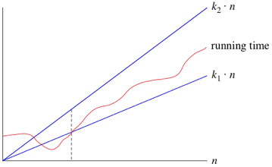

As long as these constants c1 and c2 exist, we say that the running time is Θ(n).

When you use big-Θ notation, you remove the constants and can therefore just say Θ(n).



big-O - O(f(n)) (asymptotic upper bounds)  
  
“the running time grows at most this much, but it could grow more slowly."

If a running time is O(f(n)), then for large enough $n$ , the running time is at most $c⋅f\left\langle n\right\rangle$, for some constant c:  
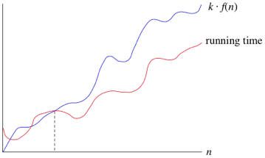

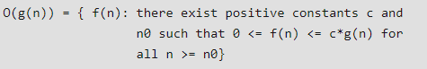

#### big-Omega - Ω(f(n)) (asymptotic lower bounds)

If a running time is Ω(f(n)) then for large enough $n$, the running time is at least $c⋅f\left\langle n\right\rangle$ for some constant c:

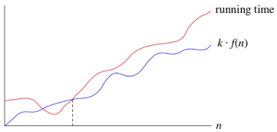

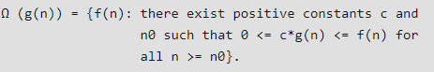

Properties of Asymptotic Notations :  
As we have gone through the definition of this three notations let’s now discuss some important properties of those notations.

#### General Properties :

If f(n) is O(g(n)) then a*f(n) is also O(g(n)) ; where a is a constant.

**Example**: f(n) = 2n²+5 is O(n²)  
**then** 7*f(n) = 7(2n²+5)  
= 14n²+35 is also O(n²)

Similarly this property satisfies for both Θ and Ω notation.  
We can say  
If f(n) is Θ(g(n)) then a*f(n) is also Θ(g(n)) ; where a is a constant.  
If f(n) is Ω (g(n)) then a*f(n) is also Ω (g(n)) ; where a is a constant.

#### Reflexive Properties :

If f(n) is given then f(n) is O(f(n)).

**Example**: f(n) = n² ; O(n²) i.e O(f(n))

Similarly this property satisfies for both Θ and Ω notation.  
We can say  
If f(n) is given then f(n) is Θ(f(n)).  
If f(n) is given then f(n) is Ω (f(n)).

#### Transitive Properties :

If f(n) is O(g(n)) and g(n) is O(h(n)) then f(n) = O(h(n)) .

**Example**: if f(n) = n , g(n) = n² and h(n)=n³  
n is O(n²) and n² is O(n³)  
**then** n is O(n³)

Similarly this property satisfies for both Θ and Ω notation.  
We can say  
If f(n) is Θ(g(n)) and g(n) is Θ(h(n)) then f(n) = Θ(h(n)) .  
If f(n) is Ω (g(n)) and g(n) is Ω (h(n)) then f(n) = Ω (h(n))

#### Symmetric Properties :

If f(n) is Θ(g(n)) then g(n) is Θ(f(n)) .

**Example**: f(n) = n² and g(n) = n²  
**then** f(n) = Θ(n²) and g(n) = Θ(n²)

**This property only satisfies for Θ notation.**

Transpose Symmetric Properties :

If f(n) is O(g(n)) then g(n) is Ω (f(n)).

**Example**: f(n) = n , g(n) = n²  
**then** n is O(n²) and n² is Ω (n)

**This property only satisfies for O and Ω notations**.

#### Some More Properties :

If f(n) = O(g(n)) and f(n) = Ω(g(n)) then f(n) = Θ(g(n))

If f(n) = O(g(n)) and d(n)=O(e(n))  
**then** f(n) + d(n) = O( max( g(n), e(n) ))  
**Example**: f(n) = n i.e O(n)  
d(n) = n² i.e O(n²)  
**then** f(n) + d(n) = n + n² i.e O(n²)

If f(n)=O(g(n)) and d(n)=O(e(n))  
**then** f(n) * d(n) = O( g(n) * e(n) )  
**Example**: f(n) = n i.e O(n)  
d(n) = n² i.e O(n²)  
then f(n) * d(n) = n * n² = n³ i.e O(n³)

### Proving the correctness of an algorithm (using e.g., induction or loop invariants)

Induction  
mathematical demonstration of the validity of a law concerning all the positive integers by proving that it holds for the integer 1 and that if it holds for an arbitrarily chosen positive integer k, it must hold for the integer k + 1.

Step 1. Show it is true for the **first one**

Step 2. Show that if **any one** is true then the **next one** is true

**Example:** is 3n−1 a multiple of 2?

**1.** Show it is true for **n=1**

$$3^{1}-1 = 3-1 = 2$$

Yes 2 is a multiple of 2. That was easy.

**2.** Assume it is true for **n=k**

$3^{k}-1$ is true

(Not necessarly true but, it is an assumption ... that we treat as a fact for the rest of this example)

Now, prove that $3^{k+1}-1$  is a multiple of 2

$3^{k+1}$ is also ${3×3}^{k}$

${3×3}^{k}$ is also ${2×3}^{k}$ + $3^{k}-1$

And each of these are multiples of 2

Because:

${2×3}^{k}$ is a multiple of 2 (we are multiplying by 2)

$3^{k}-1$ is true (we said that in the assumption above)

**Example:** Show that 2n < (n + 1)!, for n ≥ 2.

**Proof**: The base step is as follows:  
**Base Step**: n = 2: we have to check that 22 < 3!, but 4 < 6, so this is true.   
**Inductive Step:** Assume 2k < (k + 1)!, for k ≥ 2. We have  
2k+1 = 2 · 2k < 2 · (k + 1)!   
Since k ≥ 2, we have (k + 2) > 2. Therefore:  
2 · (k + 1)! < (k + 2) · (k + 1)! = (k + 2)!  
This completes the inductive step.

#### Loop invariants

An inductive statement which says something which is always true about a program loop.  
Typically written as: S(n) where n is some changing element of the loop:

* The loop counter / Index
* A loop variable which changes on each iteration

To prove a loop invariant you to prove 3 things:

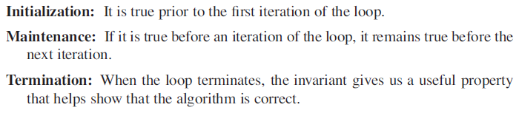

**Example:** Pre-condition: m nonnegative integer, x is a real number, i = 0, and exp = 1.  
**Program:**   
While (I ≠ m)

1. Exp = exp*x
2. I = I +1

End while

Post-condition: exp = xm

Loop-invariant: S(n) is i = n and exp = xn

**Proof:**

**Basis property**:   
n = 0, then i = 0, exp = x0 = 1, cause exp started on 1.

**Inductive property:**  
I ≠ m and S(k), then:

By 1: expnew = expold * x = xk * x = xk +1

By 2: inew = iold + 1 = k + 1

**Eventaul falsity of the Guard:**   
At each iteration, i = i + 1, and i = 0 at the start, so after m iterations we have i = m.

Correctness of the Post-Condition: Guard false implies i = m after m iterations and S(m) = xm

### Solving Recurrences (using, substitution, recursion-tree, and Master methods)

#### Substitution

We make a guess for the solution and then we use mathematical induction to prove the guess is correct or incorrect.

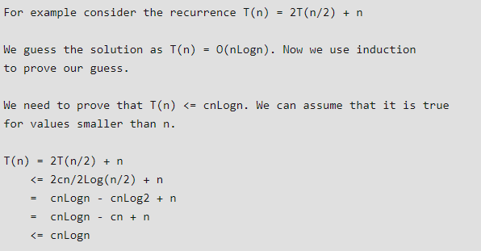

(se kapitel 4.3)

#### Recursion-Tree

In this method, we draw a recurrence tree and calculate the time taken by every level of tree. Finally, we sum the work done at all levels. To draw the recurrence tree, we start from the given recurrence and keep drawing till we find a pattern among levels. The pattern is typically a arithmetic or geometric series.

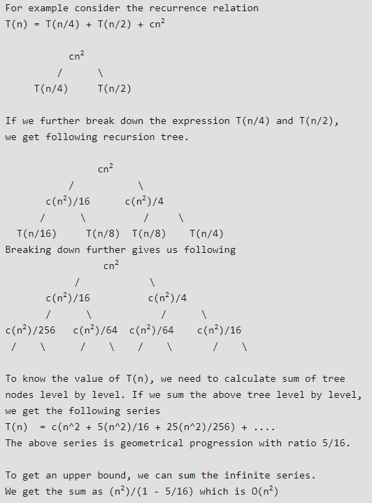

Recursion-trees bliver brugt til at lave et gæt til substitutions metoden. Her tegner man et træ hvor noderne repræsentere et del-problem (hvor ”dyrt” er et del-problem at løse). Vi summere cost i vært niveau af træet og summere vært niveau for at få den totale værdi.

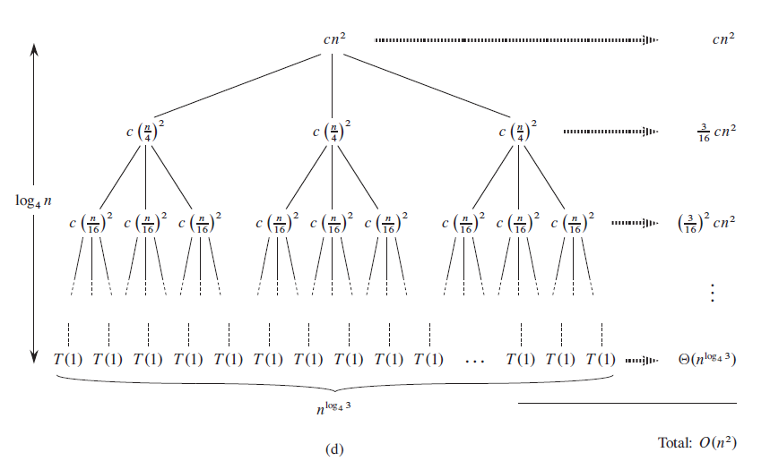

Figuren viser recurrence: T(n) = 3T (n/4) + cn^2

Denne metode er bedst brugt til at finde et gæt til at godkende med substitutions metoden.

#### Master

Master Method is a direct way to get the solution. The master method works only for following type of recurrences or for recurrences that can be transformed to following type.



The three cases:

1. If f(n) = Θ(nc) where c < Logba then T(n) = Θ(nLogba)
2. If f(n) = Θ(nc) where c = Logba then T(n) = Θ(ncLog n)
3. If f(n) = Θ(nc) where c > Logba then T(n) = Θ(f(n))

Master metoden afhænger af følgende sætning:

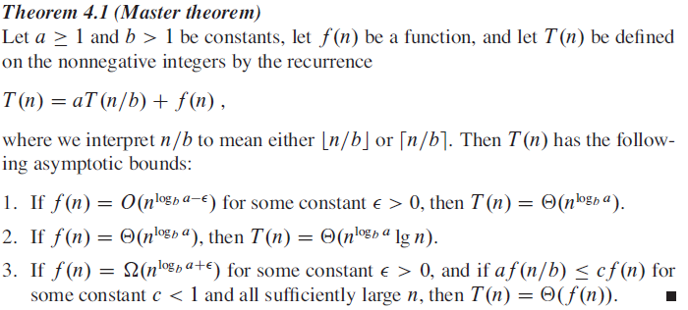

### max/min-heap property

#### Min heap

In a min heap the parent node is always smaller than or equal to its child node.

We can represent a min heap using one diemensional array

If N denotes the indes of a parent node then 2N denotes the left child node and 2N +1 denotes the right child node where N = 1,2,3…

**Example:** Input 40 60 10 20 50 30  
There are 6 elements so our heap will have 6 nodes  
We can represent the nodes of the heap in an array

|  |  |  |  |  |  |  |
| --- | --- | --- | --- | --- | --- | --- |
| 0 | 1 | 2 | 3 | 4 | 5 | 6 |
|  | 40 | 60 | 10 | 20 | 50 | 30 |

We then build the heap

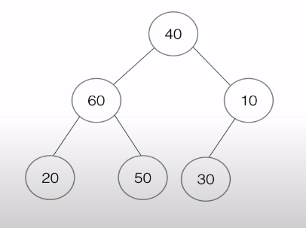

Then we transform it into an min heap

Note! - If there are N nodes then we start comparison from floor(N/2) index.  
**Example:** If N = 5   
Then floor(N/2)  
= floor(5/2) = floor(2.5) = 2 We lower down the value to nearest integer.

In this case there are 6 nodes, N = 6 so floor(6/2) = floor (3) = 3.   
We will start comparison from index 3 or the 3rd node.

Which is 10, we then ask ourselves is there any child node smaller than 10 ? No  
So we move to index 2 or the 2nd node.

Is there any node smaller than 60 ? Yes so we swap position of 20 and 60

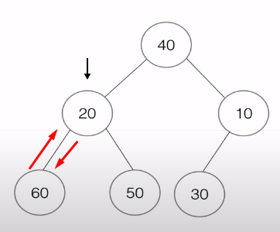

We then move to the 1st node. And swap 10 and 40.

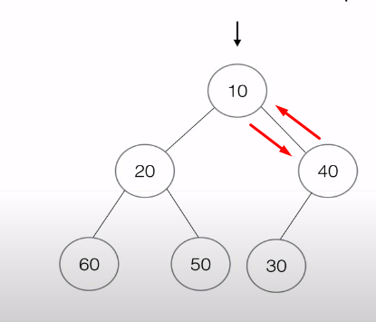

Now that we have reached the 1st node we will check wheter we have created a mini heap

Lastly we swap 30 and 40.

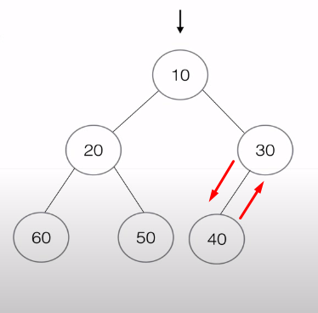

And the array will now look like

|  |  |  |  |  |  |  |
| --- | --- | --- | --- | --- | --- | --- |
| 0 | 1 | 2 | 3 | 4 | 5 | 6 |
|  | 10 | 20 | 30 | 60 | 50 | 40 |

#### Max heap

In a max heap the parent node is always great than or equal to its child node

We can represent a max heap using one dimensional array

If N denotes the indes of a parent node then 2N denotes the left child node and 2N+1 denotes the right child node where N = 1,2,3…

Samme princip som før, start comparison from floor(N/2). Og swap vis der er et child node der er større end parent node.

Array heap ouput vil være:

|  |  |  |  |  |  |  |
| --- | --- | --- | --- | --- | --- | --- |
| 0 | 1 | 2 | 3 | 4 | 5 | 6 |
|  | 60 | 50 | 30 | 20 | 40 | 10 |

### Hash functions and their properties

Hash function is a mathematical function that converts a numerical input value into another compressed numerical value. The input to the hash function is of arbitrary length but output is always of fixed length.

Values returned by a hash function are called message digest or simply hash values. The following picture illustrated hash function:

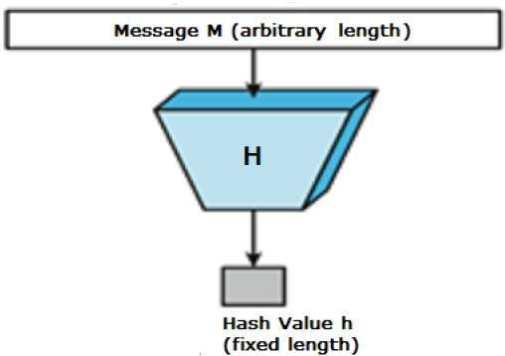

#### Features of Hash Functions

The typical features of hash functions are −

* **Fixed Length Output (Hash Value)**
  + Hash function coverts data of arbitrary length to a fixed length. This process is often referred to as **hashing the data**.
  + In general, the hash is much smaller than the input data, hence hash functions are sometimes called **compression functions**.
  + Since a hash is a smaller representation of a larger data, it is also referred to as a **digest**.
  + Hash function with n bit output is referred to as an **n-bit hash function**. Popular hash functions generate values between 160 and 512 bits.
* **Efficiency of Operation**
  + Generally for any hash function h with input x, computation of h(x) is a fast operation.
  + Computationally hash functions are much faster than a symmetric encryption.

#### Properties of Hash Functions

In order to be an effective cryptographic tool, the hash function is desired to possess following properties −

* **Pre-Image Resistance**
  + This property means that it should be computationally hard to reverse a hash function.
  + In other words, if a hash function h produced a hash value z, then it should be a difficult process to find any input value x that hashes to z.
  + This property protects against an attacker who only has a hash value and is trying to find the input.
* **Second Pre-Image Resistance**
  + This property means given an input and its hash, it should be hard to find a different input with the same hash.
  + In other words, if a hash function h for an input x produces hash value h(x), then it should be difficult to find any other input value y such that h(y) = h(x).
  + This property of hash function protects against an attacker who has an input value and its hash, and wants to substitute different value as legitimate value in place of original input value.
* **Collision Resistance**
  + This property means it should be hard to find two different inputs of any length that result in the same hash. This property is also referred to as collision free hash function.
  + In other words, for a hash function h, it is hard to find any two different inputs x and y such that h(x) = h(y).
  + Since, hash function is compressing function with fixed hash length, it is impossible for a hash function not to have collisions. This property of collision free only confirms that these collisions should be hard to find.
  + This property makes it very difficult for an attacker to find two input values with the same hash.
  + Also, if a hash function is collision-resistant **then it is second pre-image resistant.**

More info: such as Applications of Hash Functions, Popular Hash functions, Desing of Hashing Algorithms.   
<https://www.tutorialspoint.com/cryptography/cryptography_hash_functions.htm>

### Binary search tree property

Binary Search Tree, is a node-based binary tree data structure which has the following properties:

* The left subtree of a node contains only nodes with keys lesser than the node’s key.
* The right subtree of a node contains only nodes with keys greater than the node’s key.
* The left and right subtree each must also be a binary search tree.  
  There must be no duplicate nodes.



The above properties of Binary Search Tree provide an ordering among keys so that the operations like search, minimum and maximum can be done fast. If there is no ordering, then we may have to compare every key to search a given key.

<https://www.geeksforgeeks.org/binary-search-tree-set-1-search-and-insertion/>

### Red-black-tree property

* A node is either red or black
* The root and leaves (NIL) are Black
* If a node is red, then its children are black
* All paths from a node to its NIL decendants contain the same number of black nodes.

**Example:**

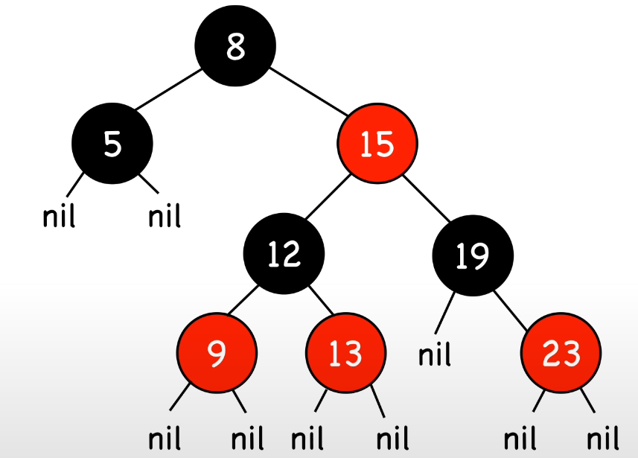

**All nodes are red or black**

**The root and leaves (Nil) are black**

**If a node is red, then its children are black**

**All paths from a node to its NIL decendants contain the same number of black nodes.**

**When counting the number of black nodes in a path you don’t count the root itself, Eg. Left side is 2 black nodes.**

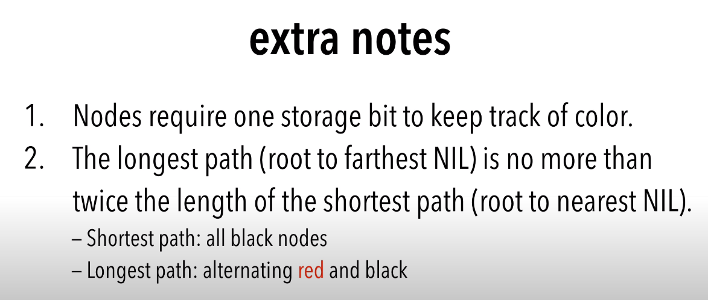

**Operations:**  
Search (O(log n)  
Insert (require rotation) (O(log n)  
Remove (require rotation) (O(log n)

**Space complexity:**   
O(N) because we only need require one extra storage bit.

**Insertions:**  
<https://www.youtube.com/watch?v=5IBxA-bZZH8>

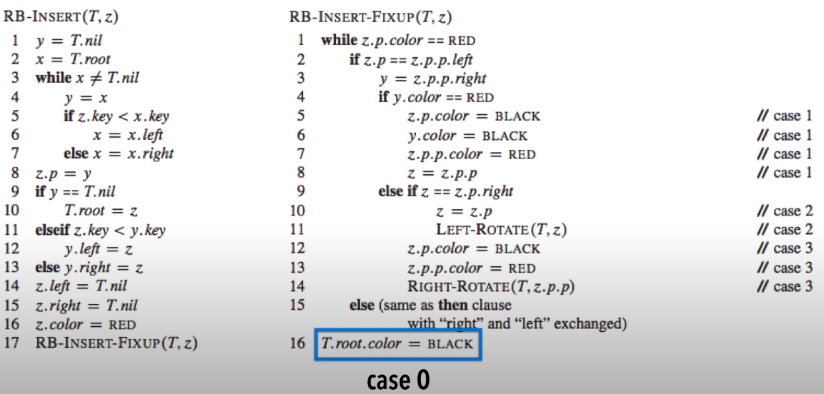

### Optimal Substructure Property

A given problems has Optimal Substructure Property if optimal solution of the given problem can be obtained by using optimal solutions of its subproblems.

**Example**: the Shortest Path problem has following optimal substructure property:  
If a node x lies in the shortest path from a source node u to destination node v then the shortest path from u to v is combination of shortest path from u to x and shortest path from x to v.

### Graph of dependencies

Representing dependencies of several objects towards each other. It is possible to derive an evaluation order or the absence of an evaluation order that respects the given dependencies from the dependency graph.

Dependency graph represent the flow of information among the attributes in a parse tree

Dependency graphs are usefull for datamining evalutioan of attributes.

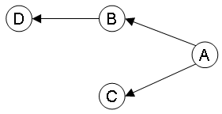

This is a graph of the UNIX family tree. Made with <http://www.graphviz.org/>

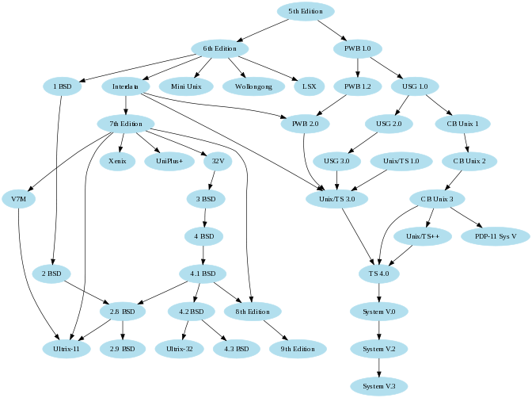

### Graphs, cycles on graphs, negative cycles, directed acyclic graphs

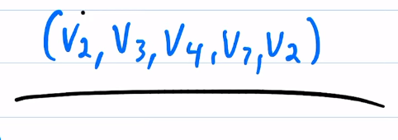

Denne er en C4,

**Simple cycles:**  
Ingen punkter må blive genbrugt udover, det sidste og først punkt som, skal være det samme.

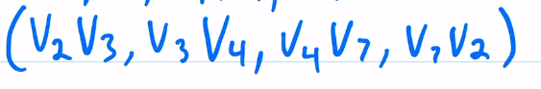

En cycles længde skal være ≥ 3

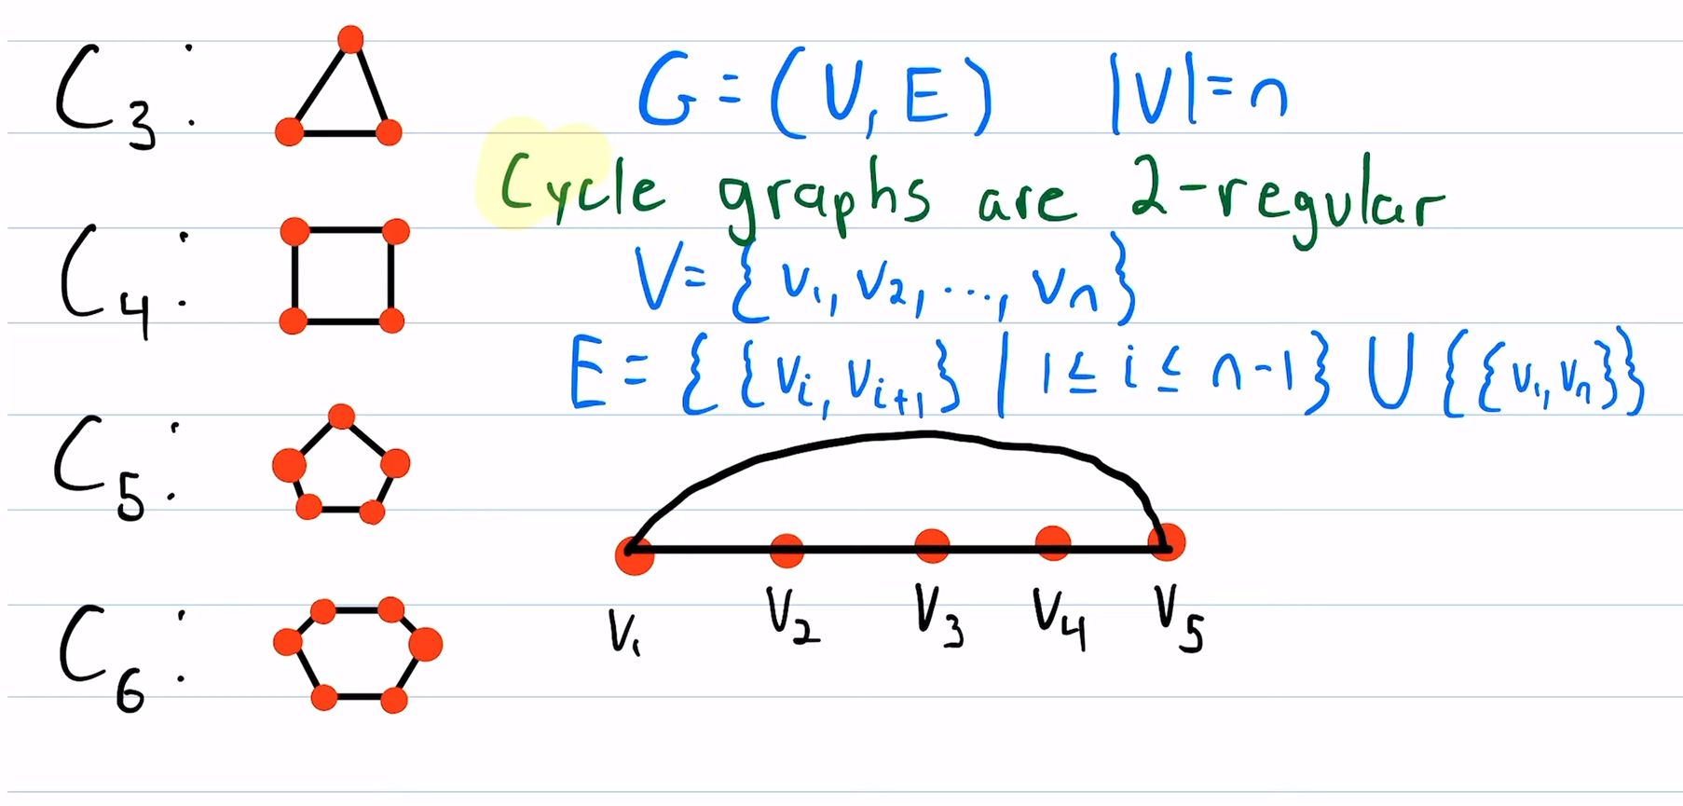

Man går ignnem punkterne fra v1 til vn og kobler dem sammen hvoraf man tilsidst tager v1 og vn og kobler dem sammen og dermed laver en Cycle graph.  
En cycle graph bliver noteret som C + et tal n, som hvis hvor mange punkter der er.

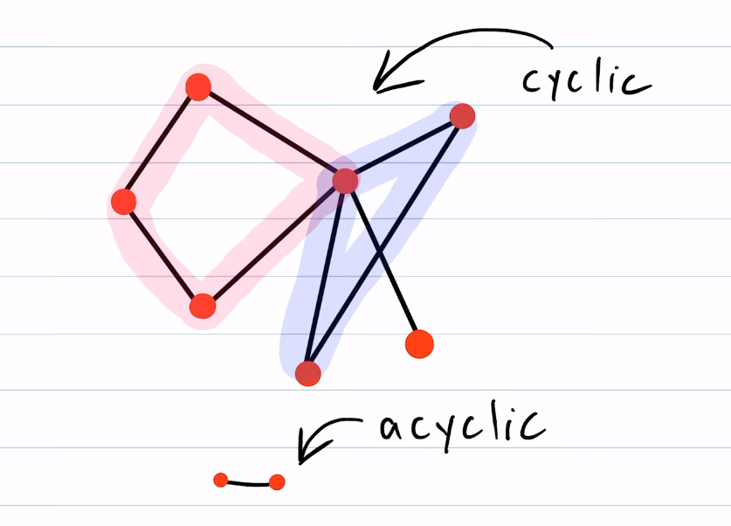

Hvis en graph har sub cycles så er den cyclic, hvis den ikke har nogle form for cycle er den acyclic

**Negative cycles:**A negative cycle is one in which the overall sum of the cycle comes negative.

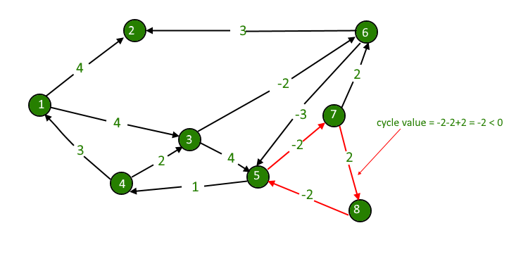

Negative weights are found in various applications of graphs. For example, instead of paying cost for a path, we may get some advantage if we follow the path.

#### directed acyclic graphs

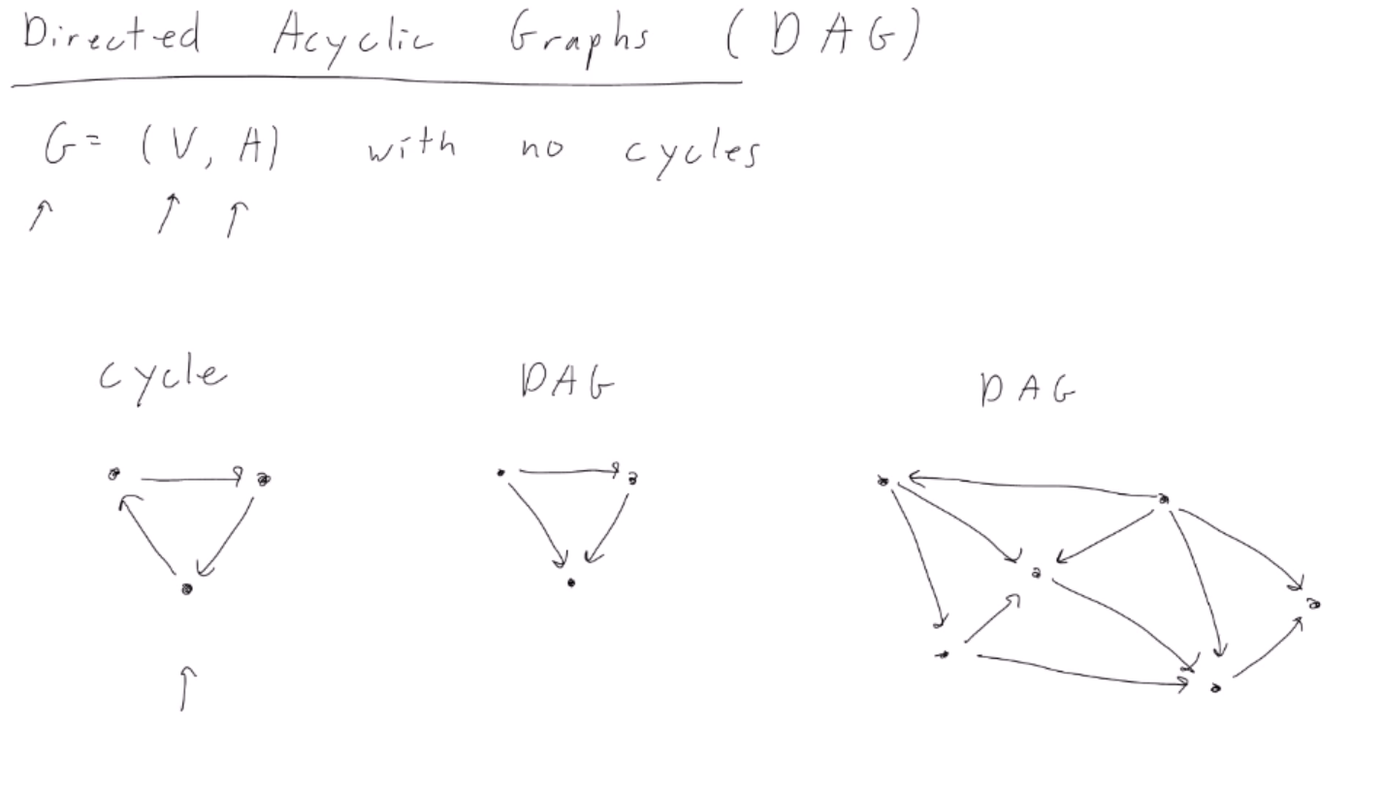

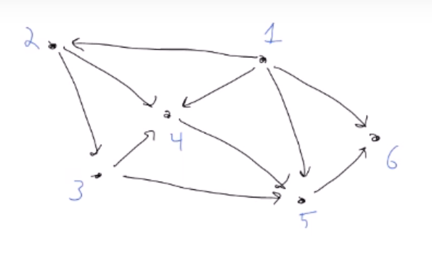

### Topological ordering on an acyclic graph

Kan omskrives til: (Topological ordering)  
Topological ordering is an ordering of the nodes in a directed graph where for each directed egde from node A to B, Node A appears Before node B in the ordering.  
A topological sort algorithm can find a topological ordering in O(V+E) time.

An topological ordering is not unique (eg. There kan be different output from the same inputs)

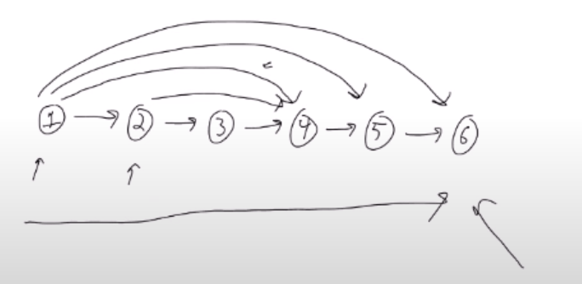

**Exemple:**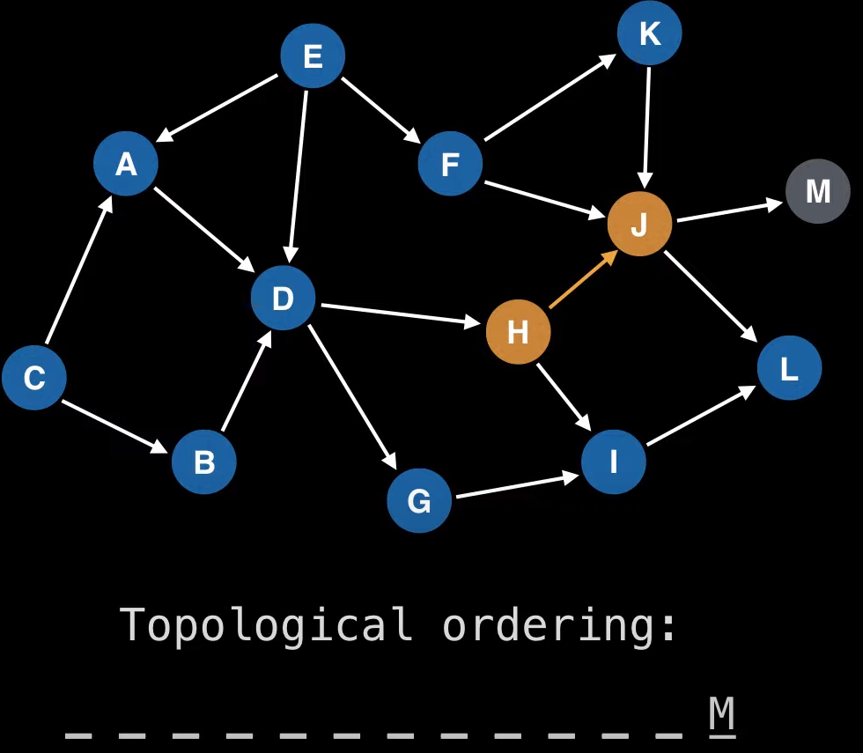

Tjekker M, har ikke andre veje indsætte M  
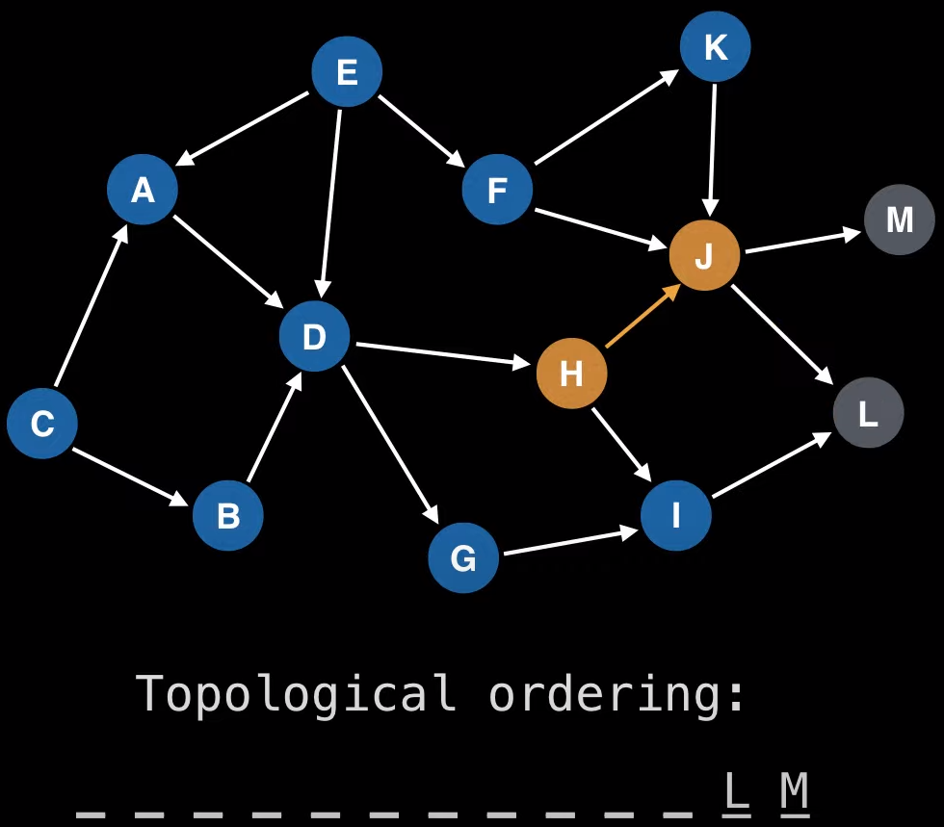  
Tjekker L har ingen andre veje indsætter L

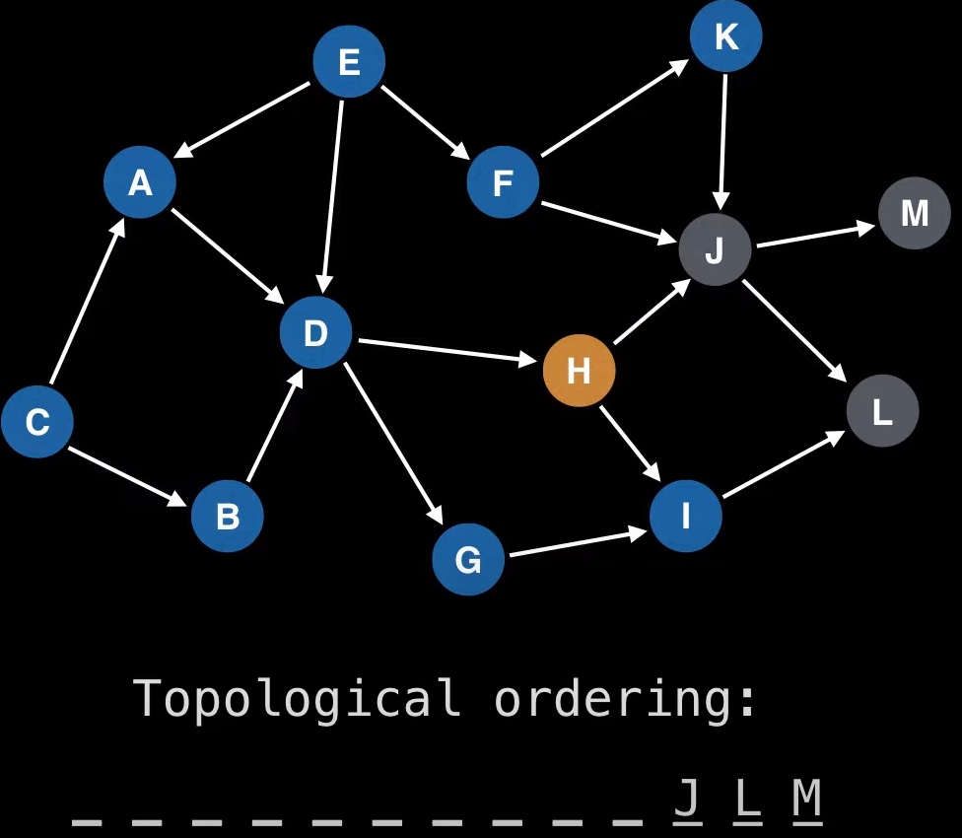

Backtrækker til J, J har ingen andre veje indsætter J.

H tjekker I, I tjekker L, men L er allerede besøgt så back track til I, og indsætte den osv.   
Og sådan forsætter man for graphen.

### shortest paths problems on graphs and weighted graphs

The shortest path problem is about finding a path between 2 vertices in a graph such that the total sum of the edges weights is minimum.

This problem could be solved easily using **(BFS)** if all edge weights were (1), but here weights can take any value. Three different algorithms are discussed below depending on the use-case.

* Bellman-Ford - sed to find the shortest paths from the source vertex to all other vertices in a weighted graph.
* Dijkstra’s algorithm - most common one is to find the shortest paths from the source vertex to all other vertices in the graph.
* Floyd-Warshalls’s Algorithm - used to find the shortest paths between between all pairs of vertices in a graph, where each edge in the graph has a weight which is positive or negative. The biggest advantage of using this algorithm is that all the shortest distances between any 2 vertices could be calculated in O(V3), where V is the number of vertices in a graph

### Rod Cutting problem

Stating the problem:

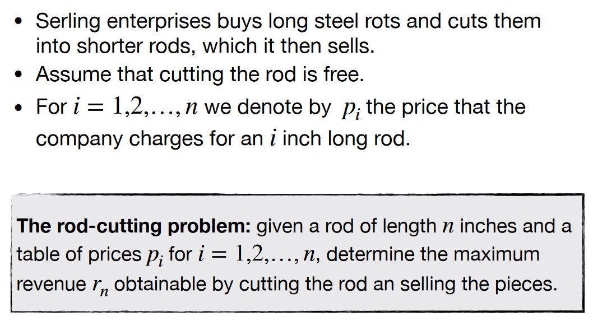

We have to find a maximum profit value for selling the rods. The pricetable looks like this:

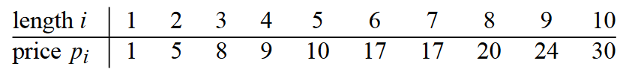

Note that *I* = length and *PI =* Price of *I* length.

Ways to cut the rod could look like this:

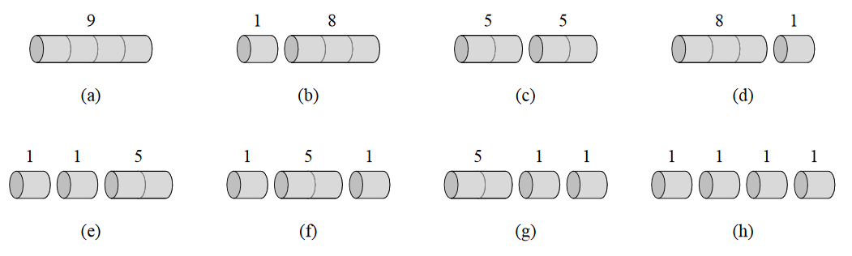

It’s possible to cut a rod of length *N* in 2*N-1* possible ways.

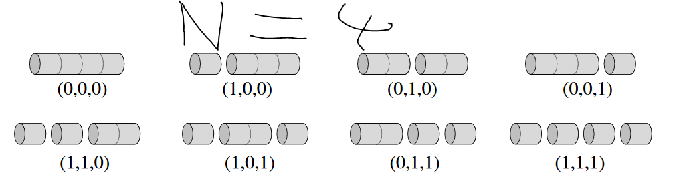

We can cut a rod of length 7 into 2 + 2 + 3 smaller rods. All of the smaller rods(Denoted by *I*) has to add up to the length of the starting rod(Which is denoted by *N)*.   
The price is then denoted by *R* which is all the prices of the smaller rods added together.

The optimal price can the be found recursively by the following algorithm:

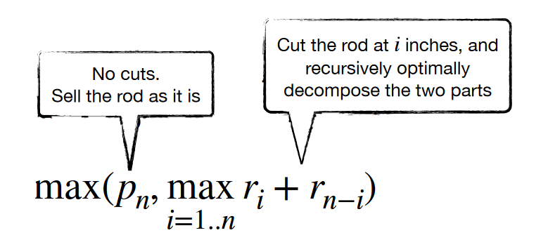

We can the look at the decomposed parts. They look like this:

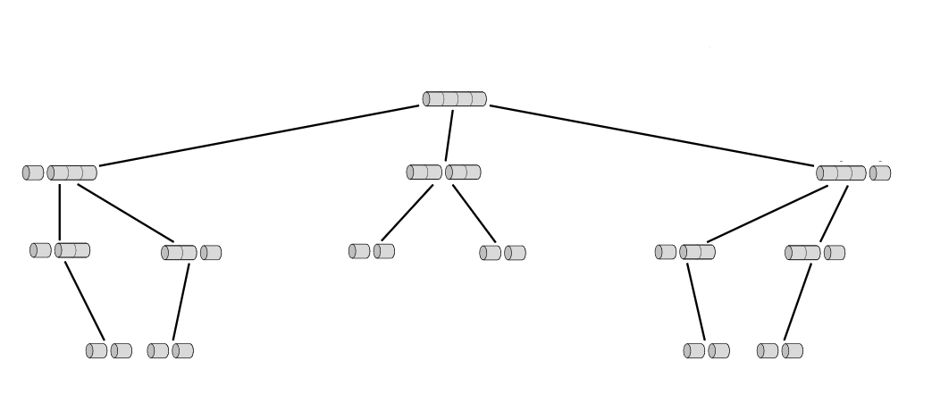

The code for this implementation looks like this:

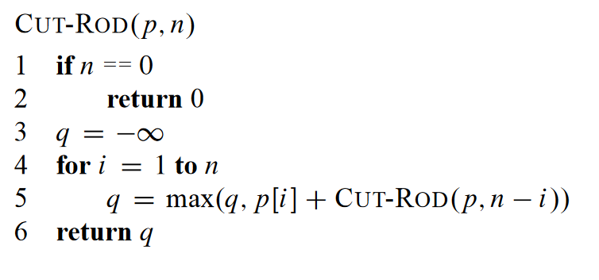

*P* = a table of prices.   
*N* = The length of the rod.

Lines 1-2 are our base case. If the length of the rod is 0, then return 0 and our recursion will stop.

On line 3 we set q to -∞ for later use. On line 4 we go from 1 to *N,* which means checking the optimal price for all the lengths up to *N.* If *N* = 7 it will first find the best price for length = 1 and then it will find it for length 1 & 2 and return the best possible value. Then it will do it for 1 & 2 & 3 and return the best possible value for those. But this is not dynamic programming as it recalculates the same problems several times as seen here:

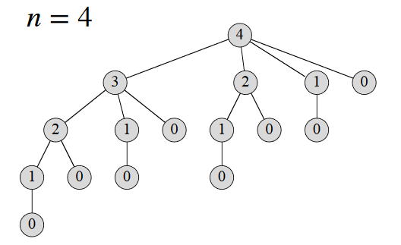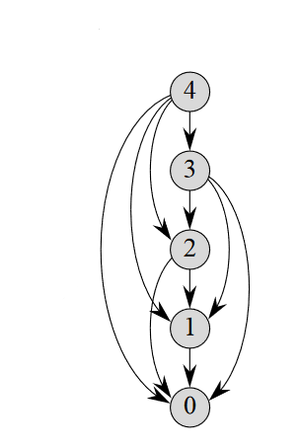

Figure 1 Subproblem graph

As seen in the subproblem graph the subproblems share subproblems. To fix that, we need to ad some memory to our Cut-Rod function, so it can look prior solutions to subproblems up.

This can be down in two ways: Top-down or bottom-up.

Top-down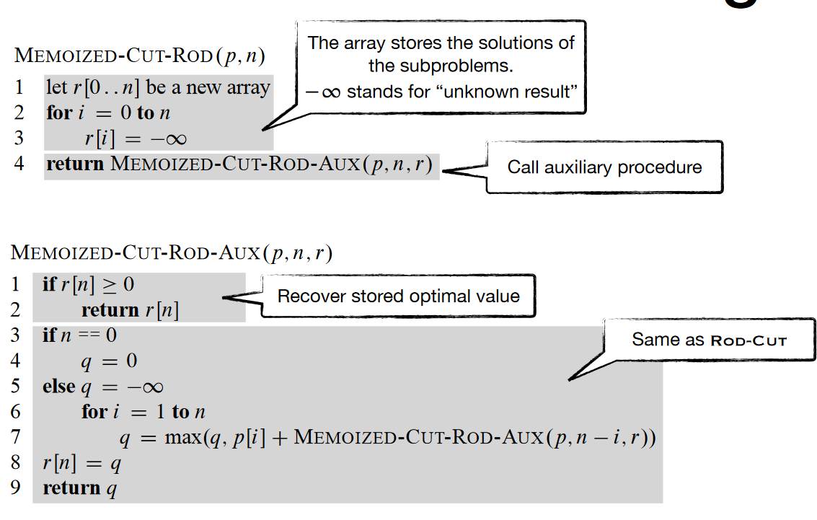

The only difference here is the array called *R* which stores the optimal values. The index values in the array corresponds to the length of the rod.

The run-time is: 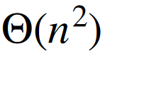

#### Bottom-up

Here we start from the smallest subproblem and work our way up.

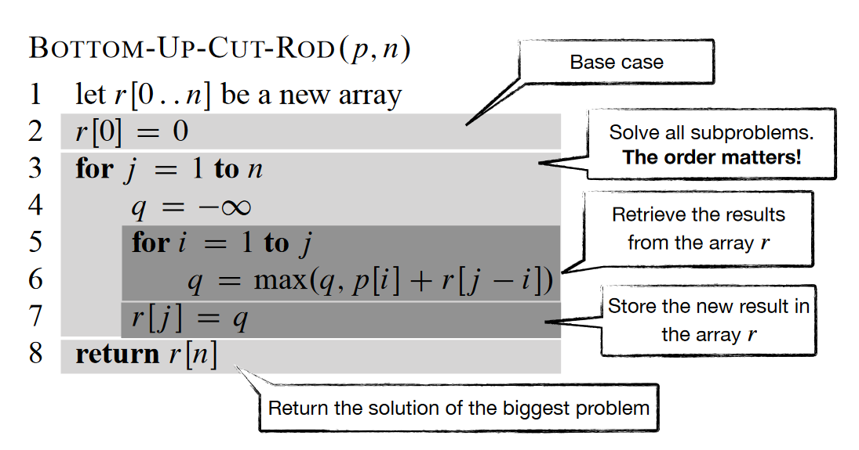

The base-case is very important, as it is the smallest subproblem. We again have the array *R* for storing previous results for subproblems.

The run-time is: 

We can now find the best value, but not exactly how to cut it. The extended version for the bottom up method prints the steps for cutting the rod.

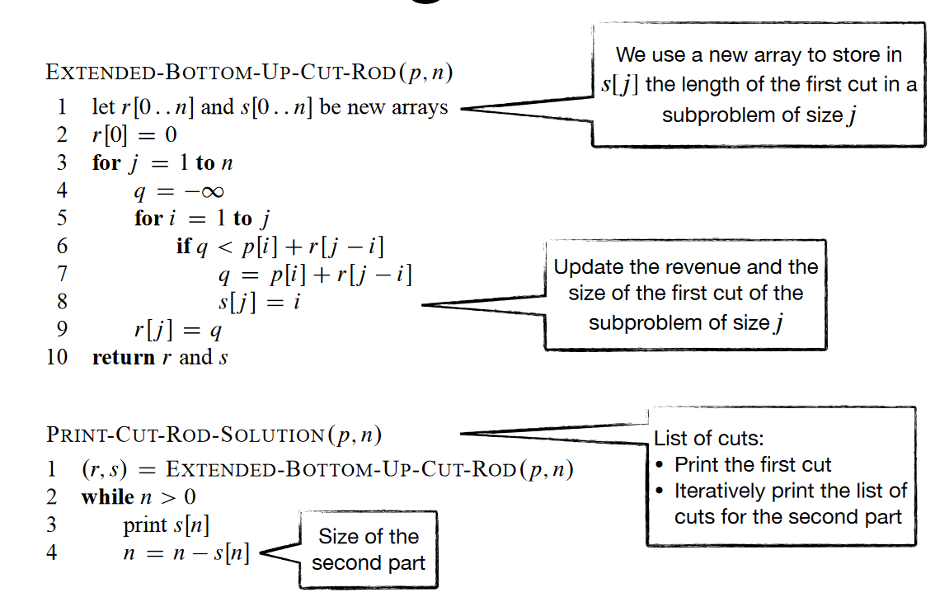

The text bobbles explain it all.

## Algorithms

### Insertion Sort

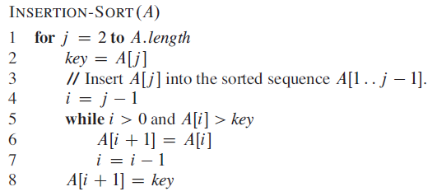

Worst-case performance = O(n2)

Best-case performance = O(n)

Average performance = O(n2)

Man starter fra venstre og arbejder mod højre i arrayet. Her sammenligner hvert element med elementet på venstre side. Man bytter elementerne hvis det ikke er i rigtig rækkefølge.

<https://www.youtube.com/watch?v=JU767SDMDvA&t=0s>

### Merge Sort

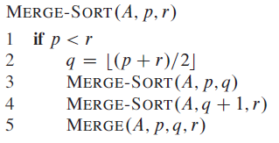

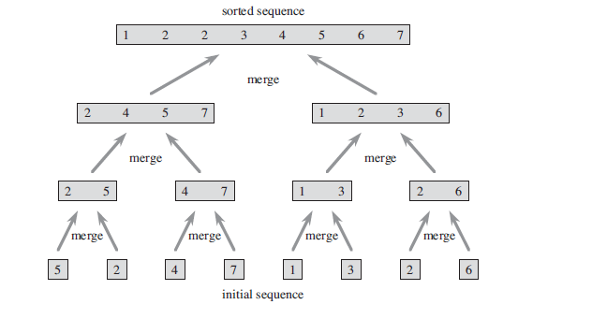

**Design**

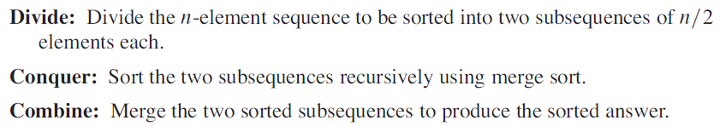

Worst-case: n * log(n)

best-case: n * log(n)

average-case: n * log(n)

stabilt: ja

**Merge hjælpefuntion**

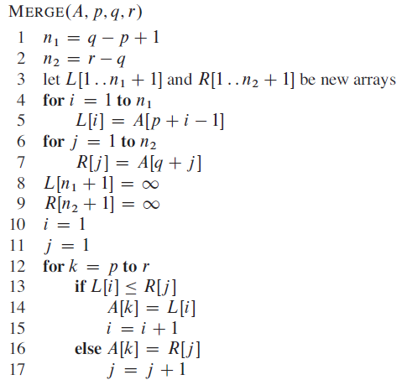

Linje 1 initialisere et subarray som går fra A[p...q] og linje 2’s subarray er fra A[p+1...r].

Linje 3 laver LEFT og RIGHT arrays, som er n1+1 og n2+1 lang (+1 fordi der tilføjes en sentinel værdi som er uendelig).

Linje 4-9 kopier subarrays A[p...q] og A[p+1...r].

Linje 10-17 bliver forklaret med en illustration fra bogen:

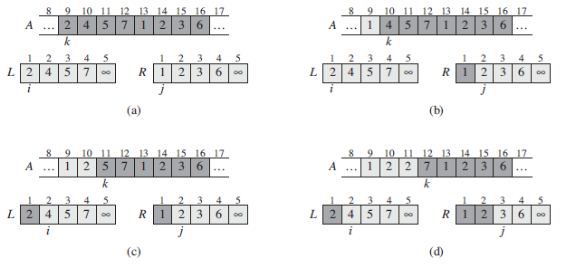

Video eksempel: <https://www.youtube.com/watch?v=JSceec-wEyw>

### Heapsort

En binær heap er et array-object som ligner et fuldt-binært træ som her:

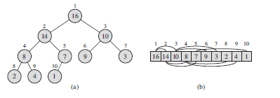

En heap ”A” har 2 værdier. A.length som beskriver mængden af elementer der kan være i A.

Og A.heap-size som beskriver hvor mange elementer der er gemt i A: 0 <= A.heap-size <= A.length.

**Parent-Child relations**

En heap har både parent, left-child og right-click. Alle typer heaps har denne egenskab. Indexet af parent, left og right er defineret således:

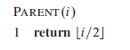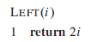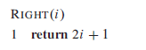

Generelt er der 2 slags heaps: min-heap og max-heap.

**Typer af heaps**

En **max-heap** skal overholde egenskabet: 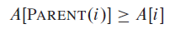

Hvilket vil sige left eller right child skal være mindre eller lig med dets parent. Dette vil sige det største element er roden af træet.

En **min-heap** skal overholde egenskabet: 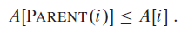

Altså det modsatte af en max-heap.

**Opretholdelse af heap-egenskabet: Max-heapify**

Max-heapify tager et array A og et index I som input. Max-heapify algoritmen er baseret på en max-heap. For en min-heap skal algoritmen ændres lidt.

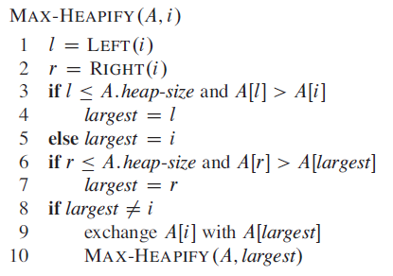

Max-heapify er illustreret sådan:

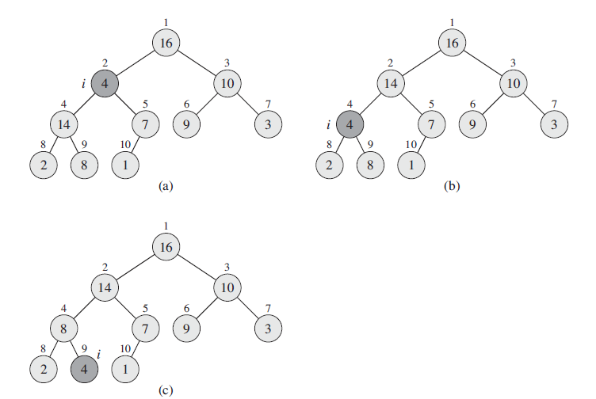

Her ser man I = 2 ikke overholdet egenskaben for en heap. Dette bliver fixet ved at bytte om på 2 og 4. Herefter bliver Max-heapify igen kaldt rekursivt på sub-træet hvor den igen bytter i = 4 og i = 9, på den måde er heapen opretholdt.

**Køretiden på max-heapify er T(n) = O(lg n) – eller O(h)**, fordi højden af en heap er lg n

**Build-max-heap**

Man bruger build-max-heap til at lave en heap. Build-max-heap tager et array A som input.

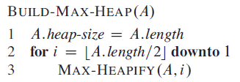

Her bliver Max-heapify kaldt iterativt på arrayet. I = A.length/2 beskriver roden af træet. Eksempel:

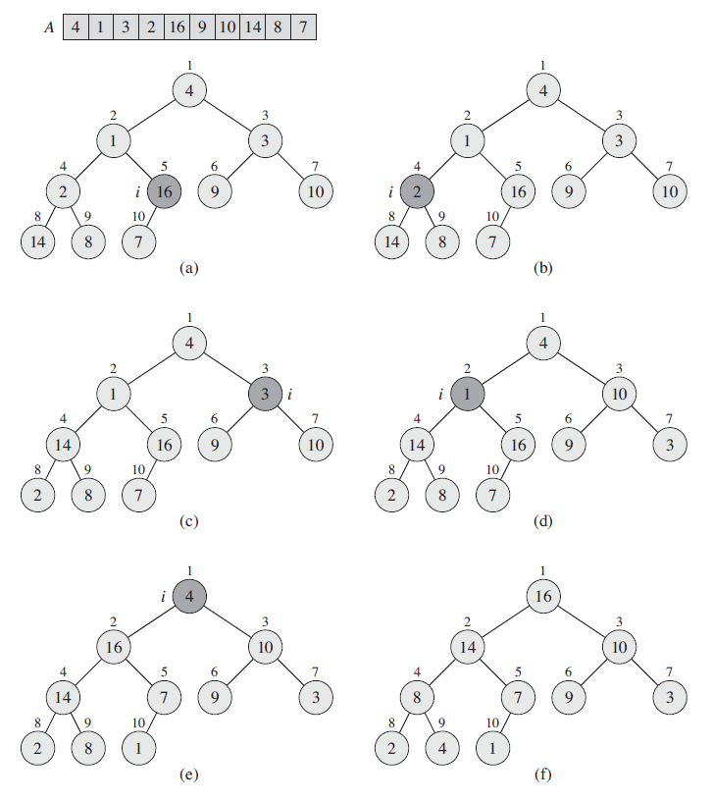

Her starter man på i = 5, fordi A.length = 10. Her efter bliver max-heapify kaldt til og med i = 1.

**Kørertiden for Build-max-heap er O(n)** – Se side 159 i bogen for bevis.

**Heap Sort algoritmen**

Heap sort tager et array A som input og giver et sorteret array i ”decending order”.

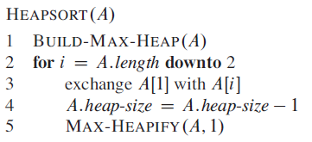

Fra heap-egentskabet ved vi, at det største element er i A[1] og placere det korrekt ved A[n] (hvor n er det sidste index). Herefter fjernes elementet fra heapen ved linje 4. Tilsidst bruger man Max-heapify til at opretholde heap-egentskaben. (herefter er A = [1...n-1]).

Kørertiden af heap sort er O(n lg n). Eksempel (efter heapen er lavet med build-max-heap):

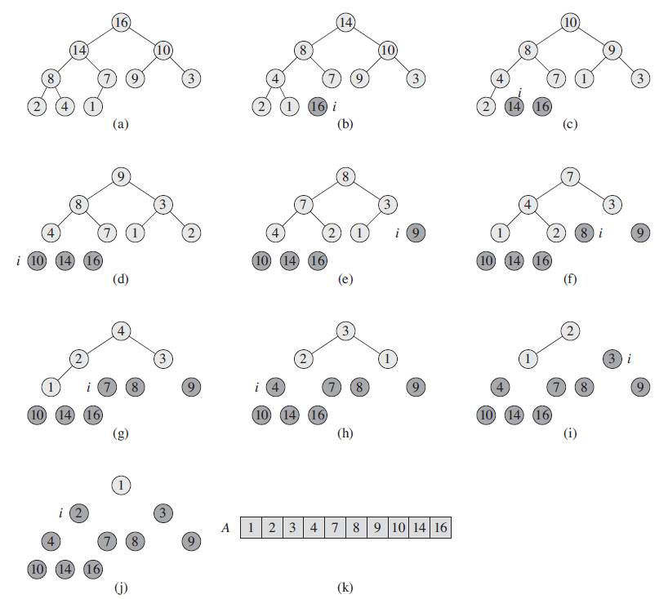

Video eksempel: <https://www.youtube.com/watch?v=MtQL_ll5KhQ>

Asending: <https://stackoverflow.com/questions/41212072/ascending-and-descending-heapsort>

### Quicksort

Quicksort er implementeret med divide and conqurer og bruger PARTITION som hjælpefunction.

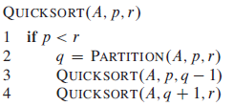

Quick sort tager et array A[p....r]. Inputs er A, og de 2 indexe.

Worst-case complexity: n^2

Average-case: n lg n

Best-case: n lg n

Stabel: nej

* Der findes også et random-quicksort som vælger et tilfældigt element som pivot.

**Partitioning**

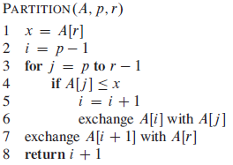

Eksempel:

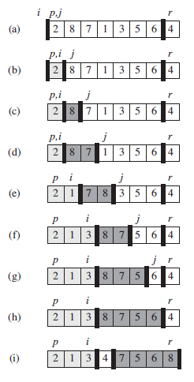

I algoritmen er x valgt som pivot element.

Video eksempel: <https://www.youtube.com/watch?v=PgBzjlCcFvc>

### Counting Sort

Counting sort tager udgangspunkt i alle input er A[1...n] dvs n = A.length. Hertil bruger Counting Sort også 2 andre arrays, et array B til output og C til ekstra rum at arbejde i.

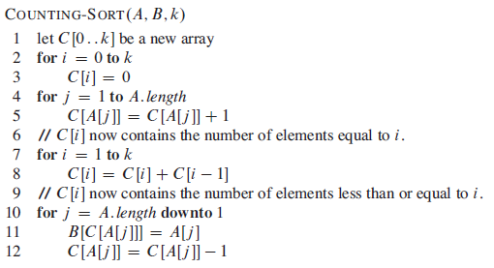

Worst, average og best-case: n + k (når k = O(n), er kørertiden n)

Hjælpe arrayet C bruges til at tælle hvor mange af hvert element der er. Herefter indsættes elementerne i B i korrekt orden.

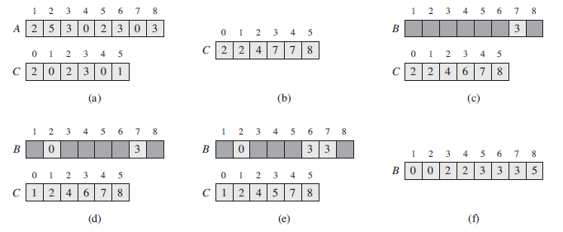

Video eksempel (meget lettere end at læse bogen): <https://www.youtube.com/watch?v=OKd534EWcdk>

### Radix Sort

Radix sort kan bruge alle stable sorterings algoritmer (dog for det meste counting sort). Radix sort er god til at sortere mere end en ting på én gang (f.eks. at sortere på datoer som har 3 værdier: dag, måned og år). Eller 3-cifret tal (fra eksemplet i bogen på s. 198).

Radix sort tager 2 inputs, et array A og et tal; d, som er antallet af cifre på tallet. Alle n-elementer i A har d cifre, hvor 1 er den laveste-orden og d er den højeste. Hvis man sortere en dato tager man først år, så måned og tilsidst dag. Her er året i datoen den højeste orden og dagen er den laveste. 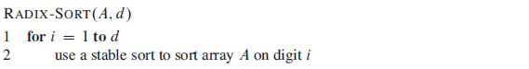

Kørertiden på Radix Sort er Theta(d(n+k)) hvis man bruger counting sort. (bevis på s. 198 i bogen).

Videoer til Radix Sort:

<https://www.youtube.com/watch?v=XiuSW_mEn7g>

<https://www.youtube.com/watch?v=nu4gDuFabIM>

### Breadth-First Search

BFS finds the shortest path, aka the minimal amount of edges to travel to reach a point in a graph.

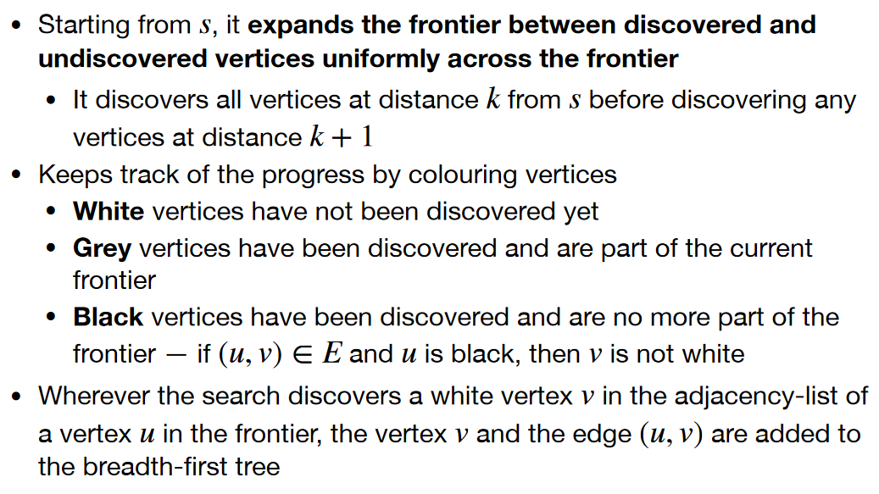

We have the graph *G = (V, E)* and a starting vertex *s*.

On lines 1 - 4 all vertices are initialized. The colors are explained on page 1.

*u.d =* the length from *s* to that vertex and *u.π* is the previous vertex.

On lines 5 – 7 the start vertex is initialized.

On lines 8 – 9 the array *Q*  is initialized and the start vertex *s* is *Enqueued*.

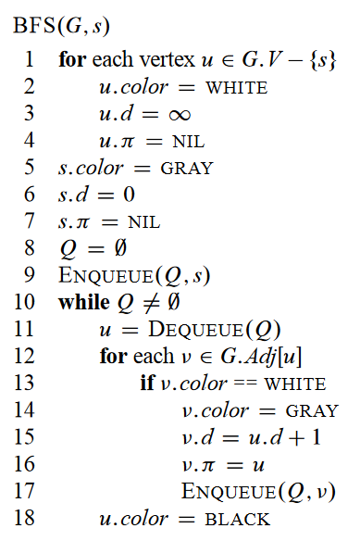The while-loop continues until there is no more vertices. First on line 11 it removes the head of *Q* with *Dequeue* and sets *u* equal it*.*

Then the for-loop on line 12 goes for all adjacent vertices to *u.* If it’s a new vertex(if its white) it updates it color, the length from s to the vertex(*d*) and the previous vertex. Afterwards it enqueues the vertex.

If the vertex is grey, which means its already visited its color is set to black on line 18.

#### Example

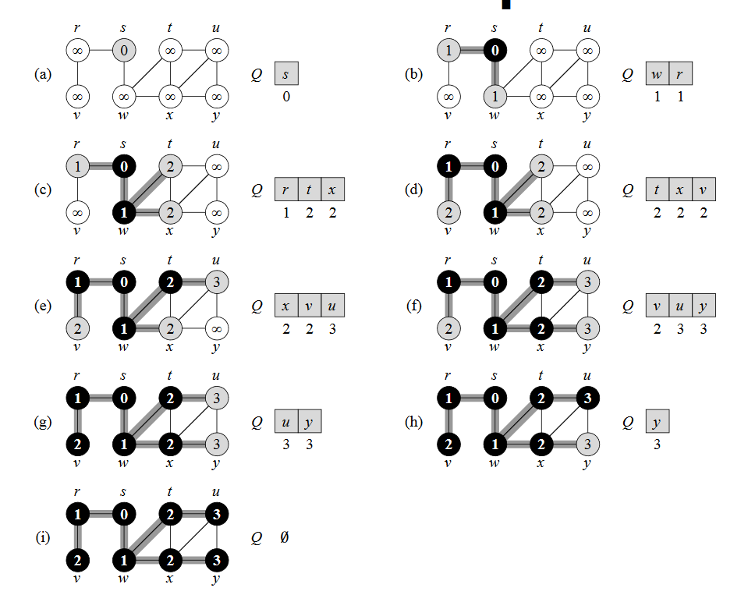

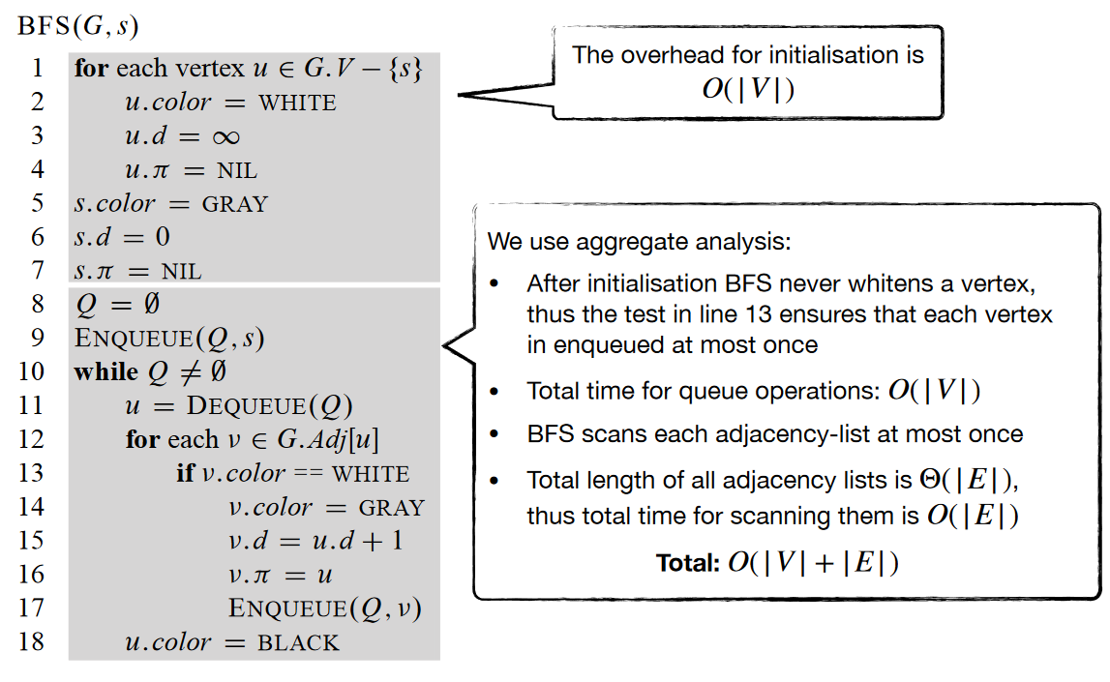

### Depth-first Search

DFS searches deeper in the graph. It explores edges for each found vertex when it finds it.

When all ’s edges have been explored, it “backtracks” to explore edges living the vertex from which was explored

It starts from a vertex, discover all its edges, proceeds recursively on all adjacent vertices which have not been discovered yet

It keeps track of the process by colouring vertices

* White vertices have not been discovered yet
* Grey vertices have been discovered but not totally explored
* Black vertices have been totally explored— if (u, v) ϵ *E* and *u* is black, then *v* is not white

Additionally, DFS records when it discovers vertex *u* by setting setting a timestamp

* *u.d* records the time when *u* becomes grey
* *u.f* records the time when *u* becomes black
* For each vertex *u.d < u.f*

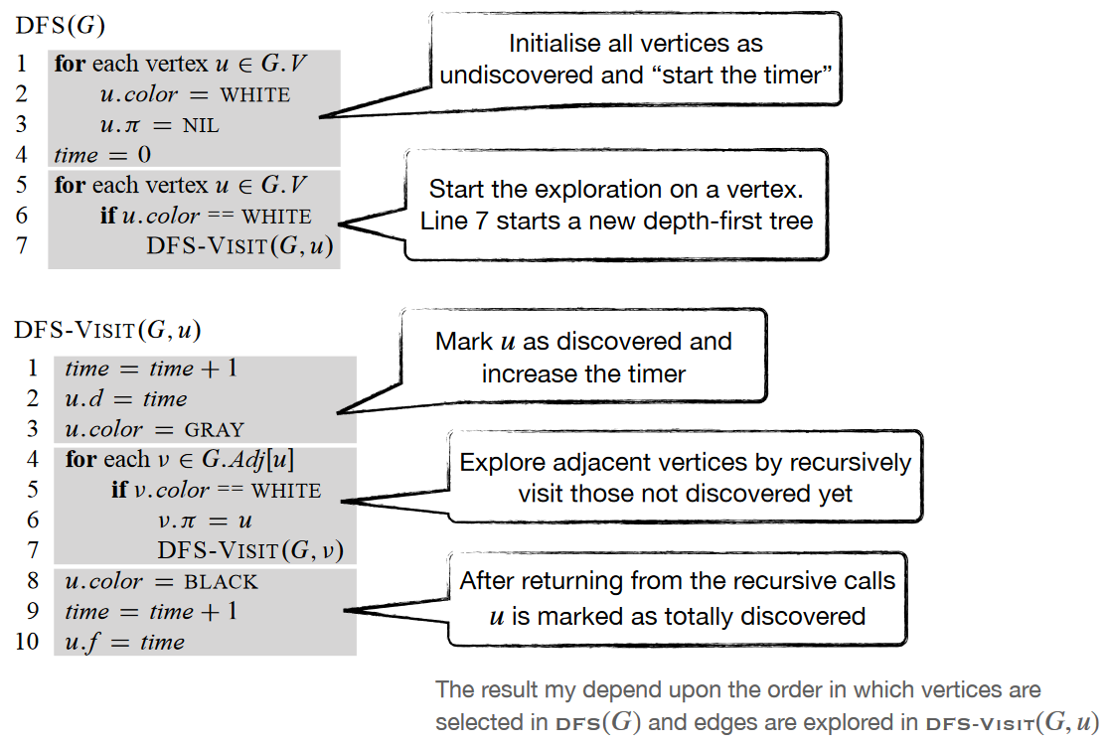

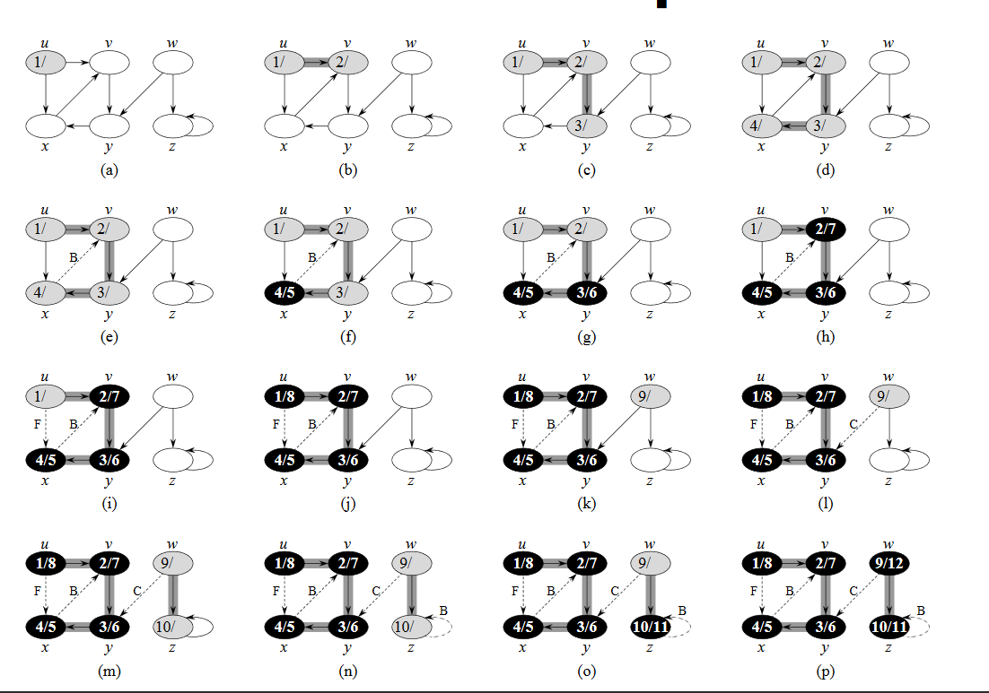

Dotted paths are ignored, as the vertex is already discovered(grey). The algorithm backtracks and sets the vertex to black.

DFS runtime is 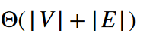

### Topological Sorting

You must read about DFS before this to understand.

To do TS the graph must be acyclic, which means no loops.

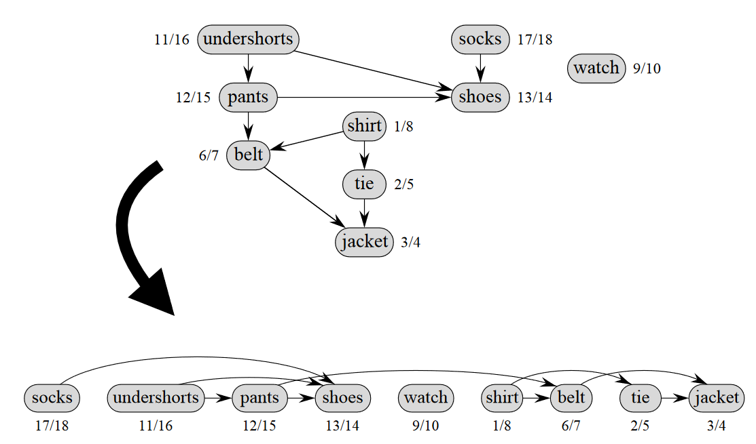

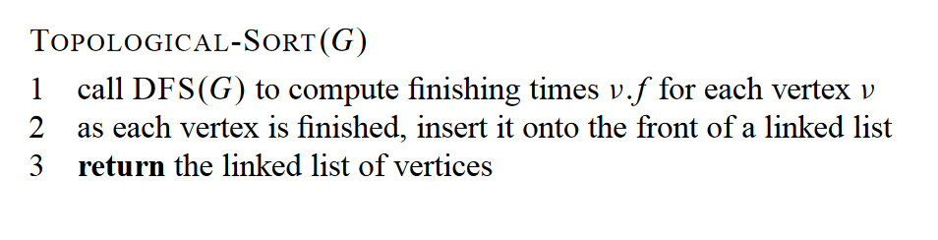

Its important to note that it’s a linked list, where there are pointers to predecessors and children.

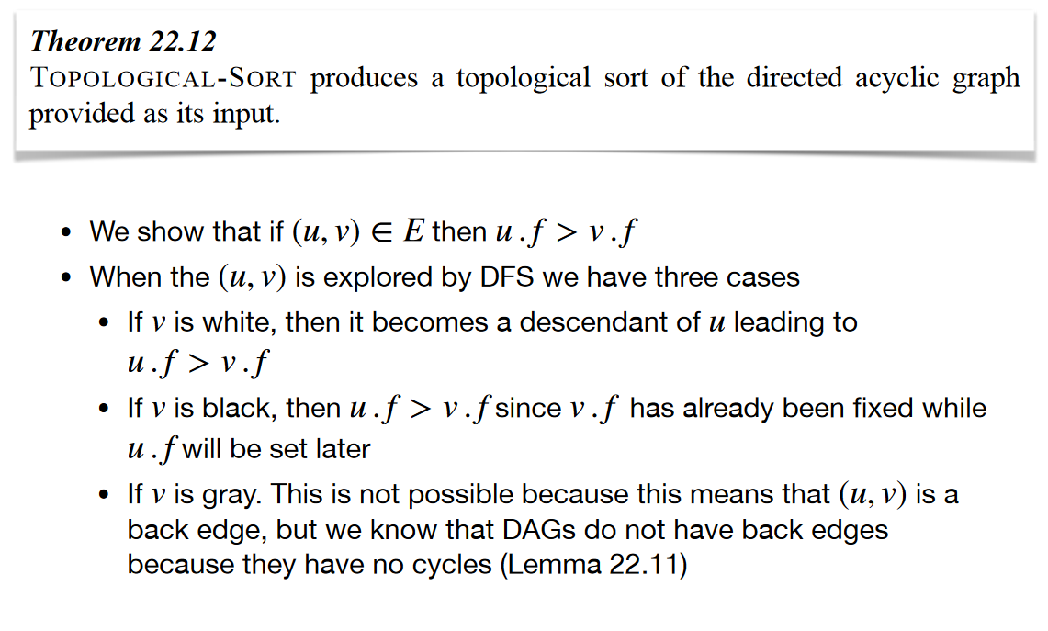

### Computing Strongly Connected Components

A directed graph is strongly connected if there is a path between all pairs of vertices. A strongly connected component (**SCC**) of a directed graph is a maximal strongly connected subgraph.

For example, there are 3 SCCs in the following graph.

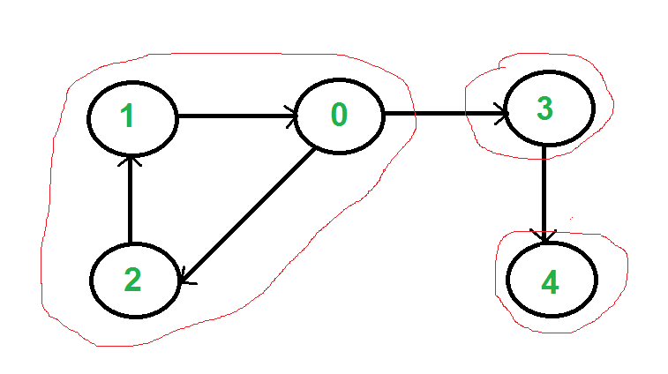

We can find all strongly connected components in O(V+E) time using Kosaraju’s algorithm. Following is detailed Kosaraju’s algorithm.

1. Create an empty stack ‘S’ and do Depth-First Search (DFS) traversal of a graph. In DFS traversal, after calling recursive DFS for adjacent vertices of a vertex, push the vertex to stack. In the above graph, if we start DFS from vertex 0, we get vertices in stack as 1, 2, 4, 3, 0.
2. Reverse directions of all arcs to obtain the transpose graph.
3. One by one pop a vertex from S while S is not empty. Let the popped vertex be ‘v’. Take v as source and do DFS (call [DFSUtil(v)](https://www.geeksforgeeks.org/depth-first-traversal-for-a-graph/)). The DFS starting from v prints strongly connected component of v. In the above example, we process vertices in order 0, 3, 4, 2, 1 (One by one popped from stack).

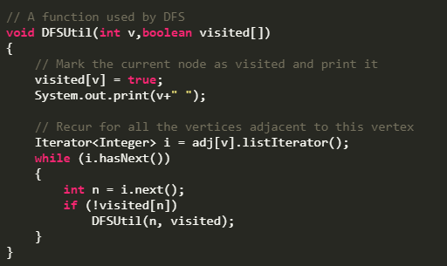

DFSUtil

**How does this work?**  
The above algorithm is DFS based. It does DFS two times. DFS of a graph produces a single tree if all vertices are reachable from the DFS starting point. Otherwise DFS produces a forest. So DFS of a graph with only one SCC always produces a tree. The important point to note is DFS may produce a tree or a forest when there are more than one SCCs depending upon the chosen starting point. For example, in the above diagram, if we start DFS from vertices 0 or 1 or 2, we get a tree as output. And if we start from 3 or 4, we get a forest. To find and print all SCCs, we would want to start DFS from vertex 4 (which is a sink vertex), then move to 3 which is sink in the remaining set (set excluding 4) and finally any of the remaining vertices (0, 1, 2). So how do we find this sequence of picking vertices as starting points of DFS? Unfortunately, there is no direct way for getting this sequence. However, if we do a DFS of graph and store vertices according to their finish times, we make sure that the finish time of a vertex that connects to other SCCs (other that its own SCC), will always be greater than finish time of vertices in the other SCC. For example, in DFS of above example graph, finish time of 0 is always greater than 3 and 4 (irrespective of the sequence of vertices considered for DFS). And finish time of 3 is always greater than 4. DFS doesn’t guarantee about other vertices, for example finish times of 1 and 2 may be smaller or greater than 3 and 4 depending upon the sequence of vertices considered for DFS. So to use this property, we do DFS traversal of complete graph and push every finished vertex to a stack. In stack, 3 always appears after 4, and 0 appear after both 3 and 4.  
In the next step, we reverse the graph. Consider the graph of SCCs. In the reversed graph, the edges that connect two components are reversed. So the SCC {0, 1, 2} becomes sink and the SCC {4} becomes source. As discussed above, in stack, we always have 0 before 3 and 4. So if we do a DFS of the reversed graph using sequence of vertices in stack, we process vertices from sink to source (in reversed graph). That is what we wanted to achieve and that is all needed to print SCCs one by one.

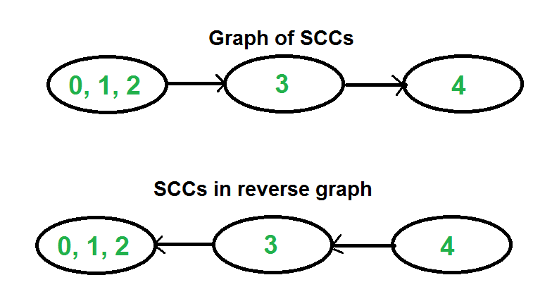

**Time Complexity:**The above algorithm calls DFS, finds reverse of the graph and again calls DFS. DFS takes O(V+E) for a graph represented using adjacency list. Reversing a graph also takes O(V+E) time. For reversing the graph, we simple traverse all adjacency lists.

<https://www.geeksforgeeks.org/strongly-connected-components/>

### Bellman-Ford Algorithm

Bellman-Ford works for graphs with negative weight edges..

Bellman-Ford is also simpler than Dijkstra and suites well for distributed systems. But time complexity of Bellman-Ford is O(VE), which is more than Dijkstra.

* Solves the single-source shortest-path problem in the general case in which weights may be negative.
* If there is a cycle, the algorithm indicates that no solution exists
* If there is no such a cycle the algorithm produces a shortest-path tree rooted at s ∈ v

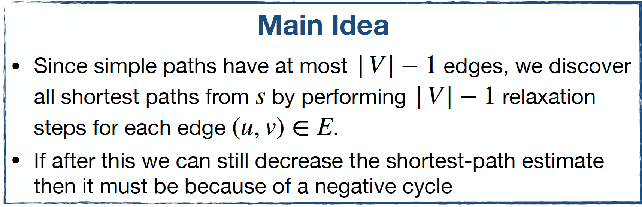

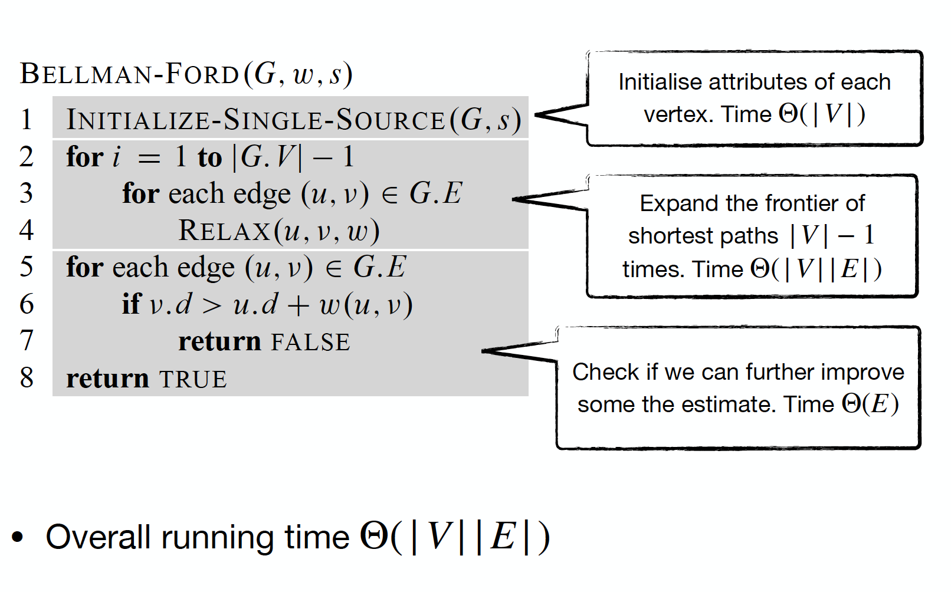

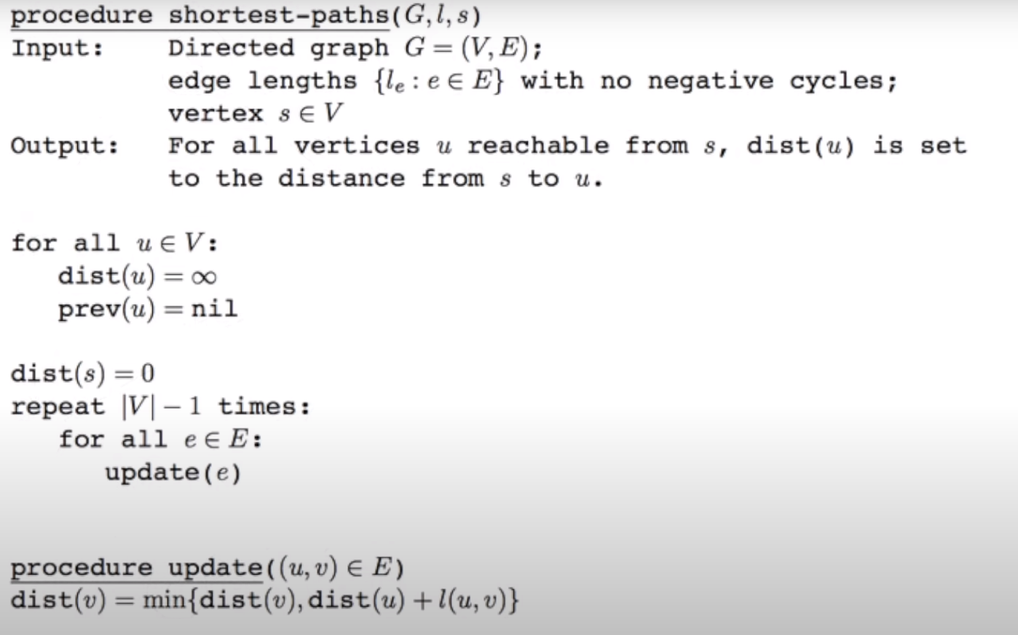

*Pseudocode: for Bellman-ford*

Time complexity: O(|V|*|E|)

**Example:**

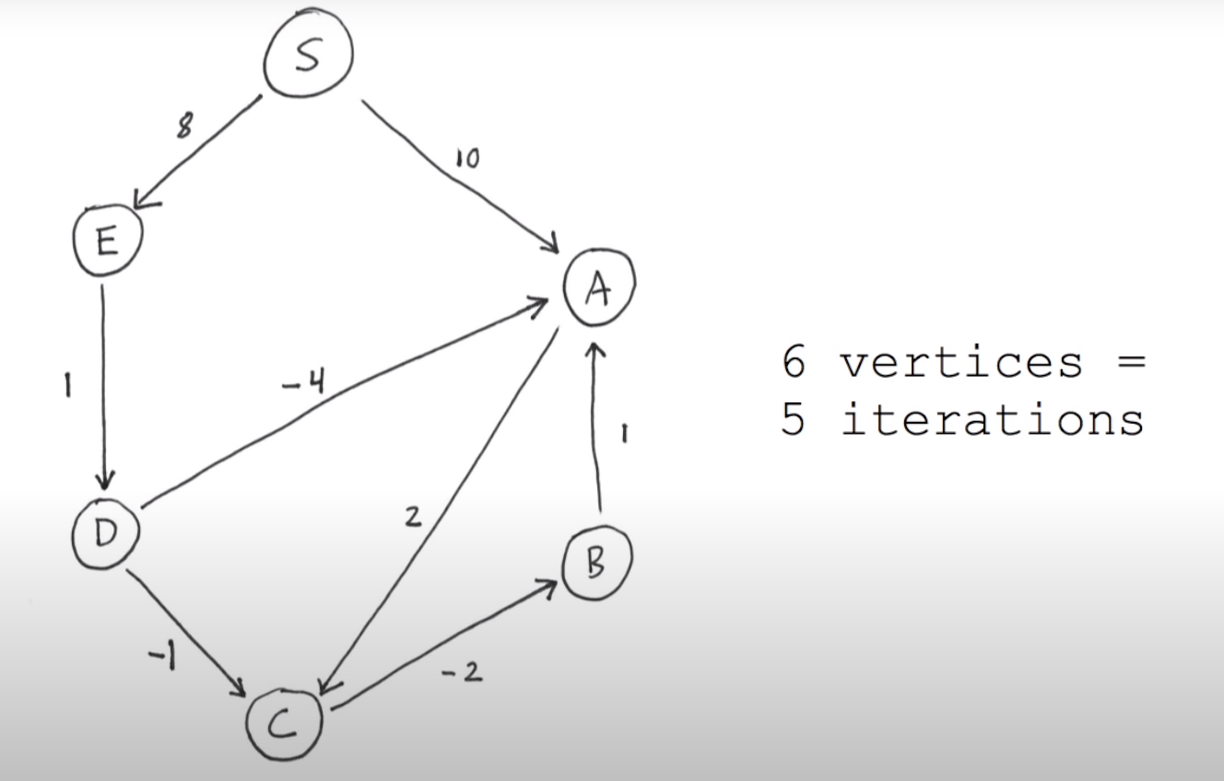

Before first iteration:

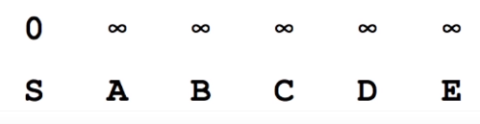

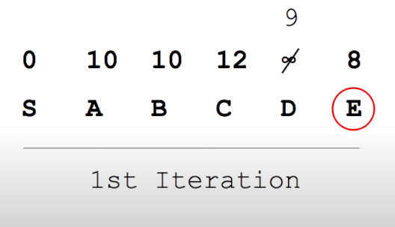

D makes impreovements for a and c.

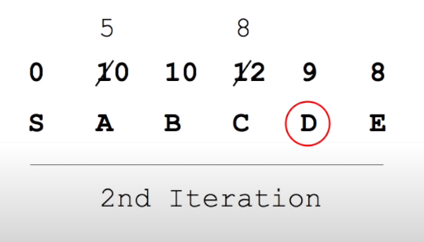

Now that c is improved the path to b is aswell

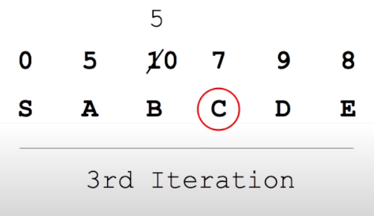

Finished at iteration 4, so it was faster than worst running time.

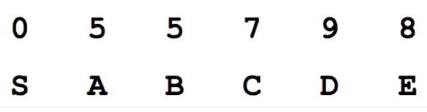

### Dijkstra’s algorithm

Given a graph and a source vertex in the graph, find shortest paths from source to all vertices in the given graph.

We maintain two sets, one set contains vertices included in shortest path tree, other set includes vertices not yet included in shortest path tree. At every step of the algorithm, we find a vertex which is in the other set (set of not yet included) and has a minimum distance from the source.

Below are the detailed steps used in Dijkstra’s algorithm to find the shortest path from a single source vertex to all other vertices in the given graph.

* Solves the single-source shortest-path problem assuming edge weights are nonnegative
* Hence, no negative cycles
* It generalises BFS over weighted graphs

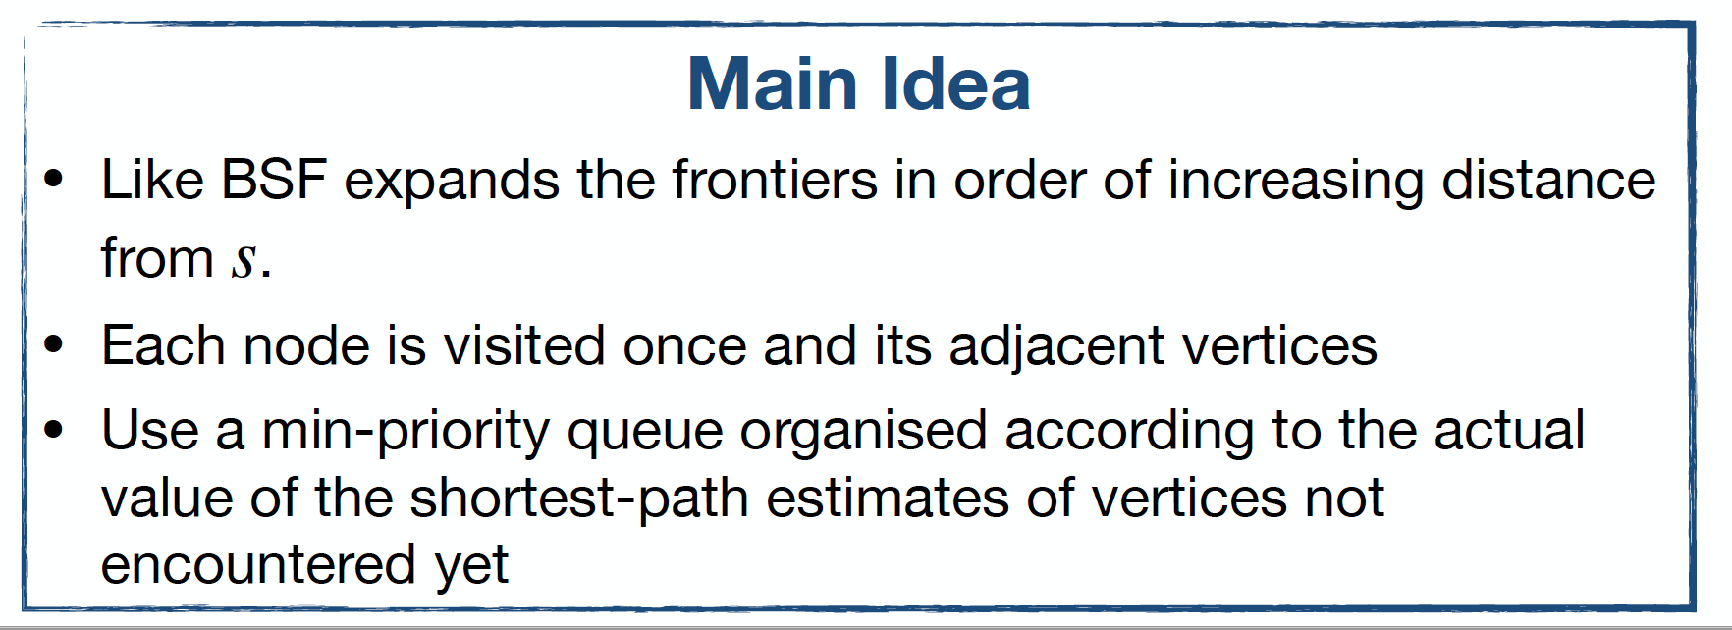

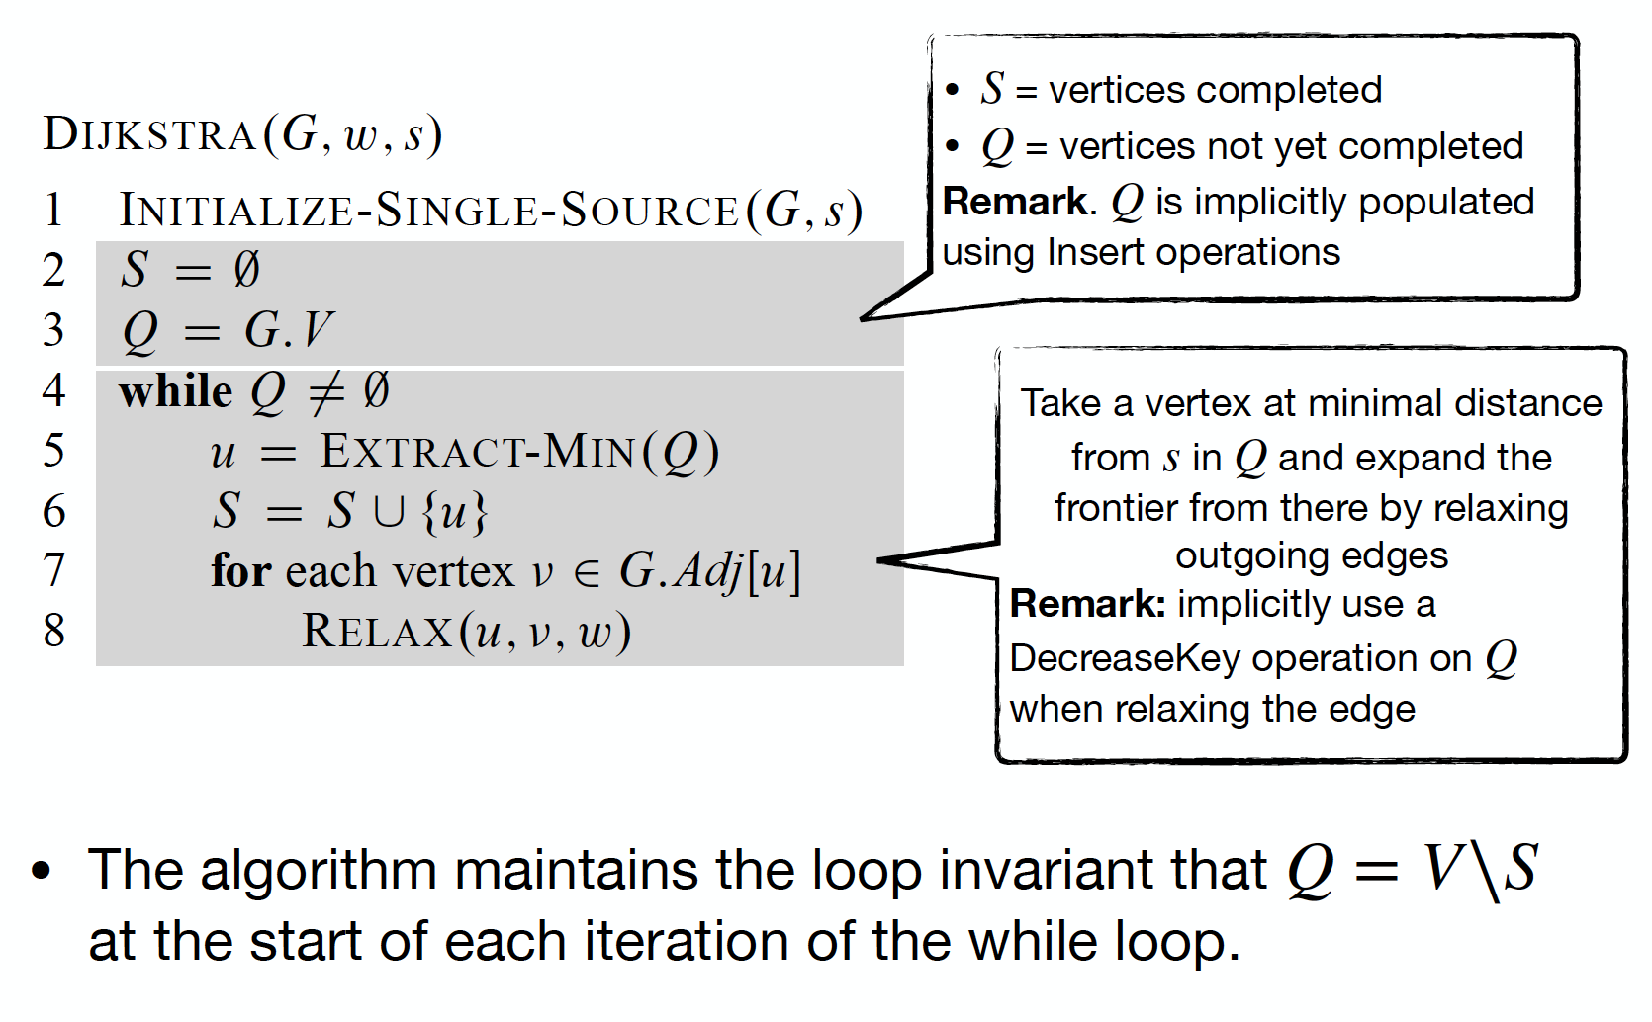

#### Runtime

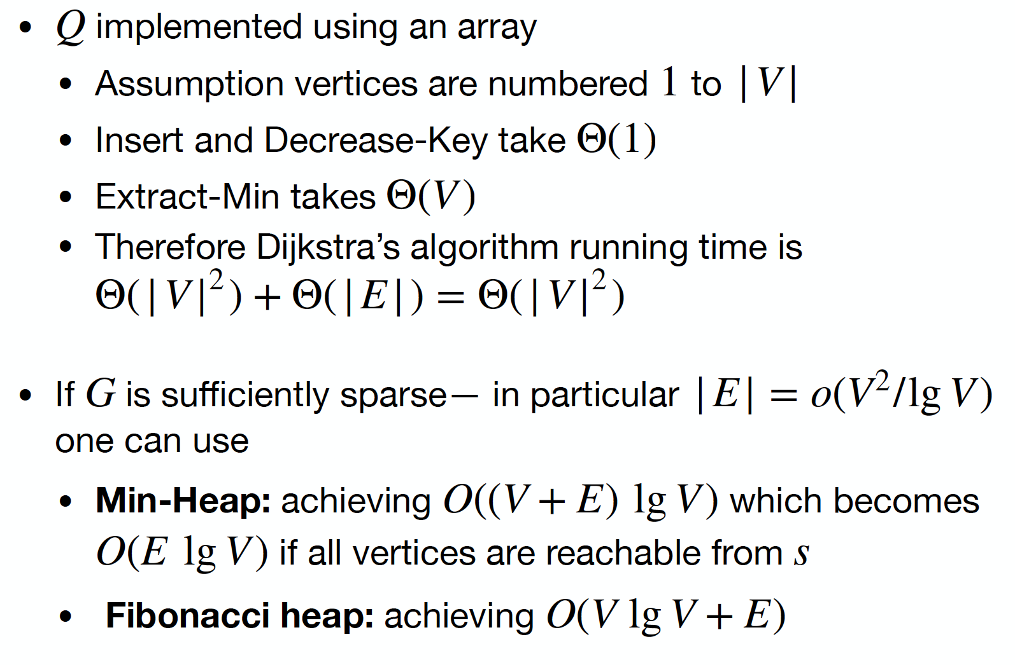

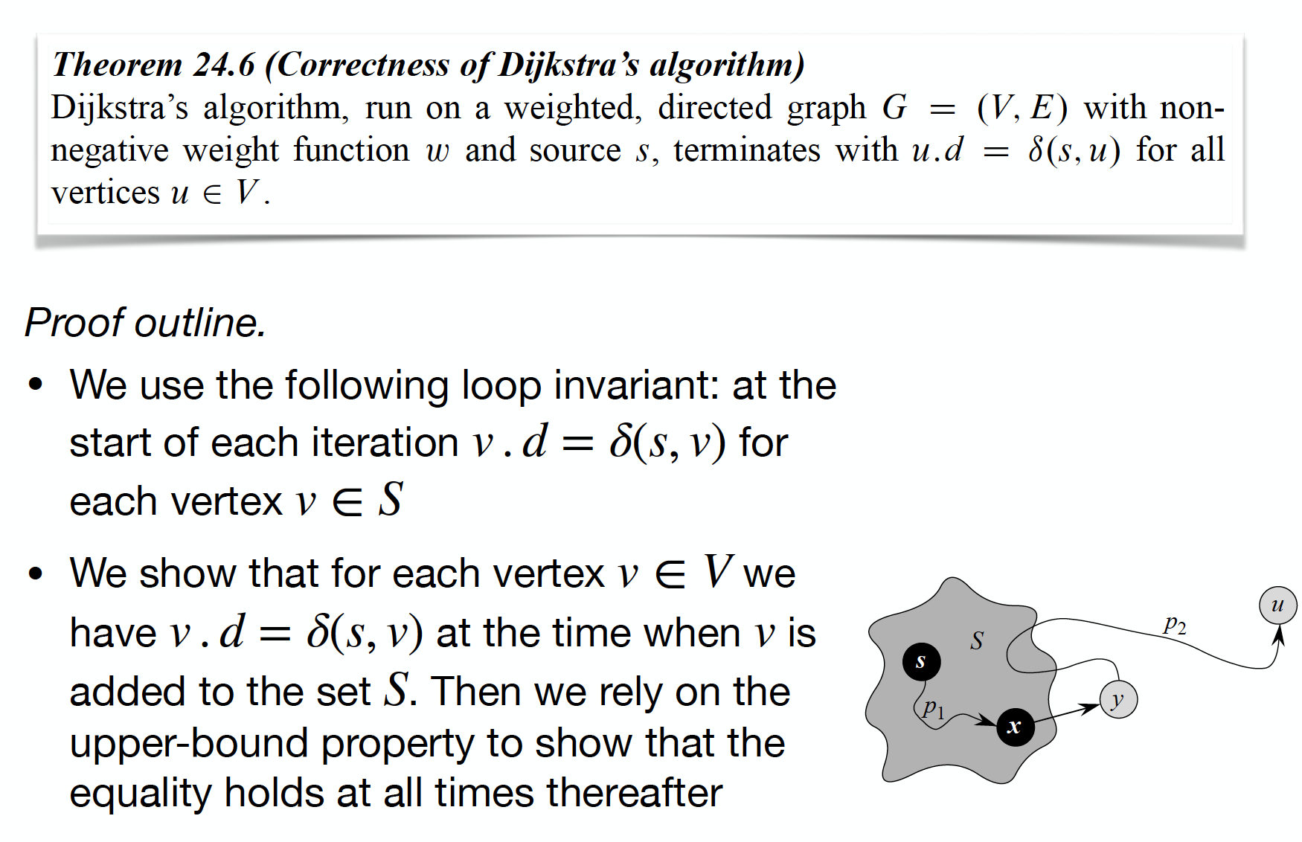

**Example:**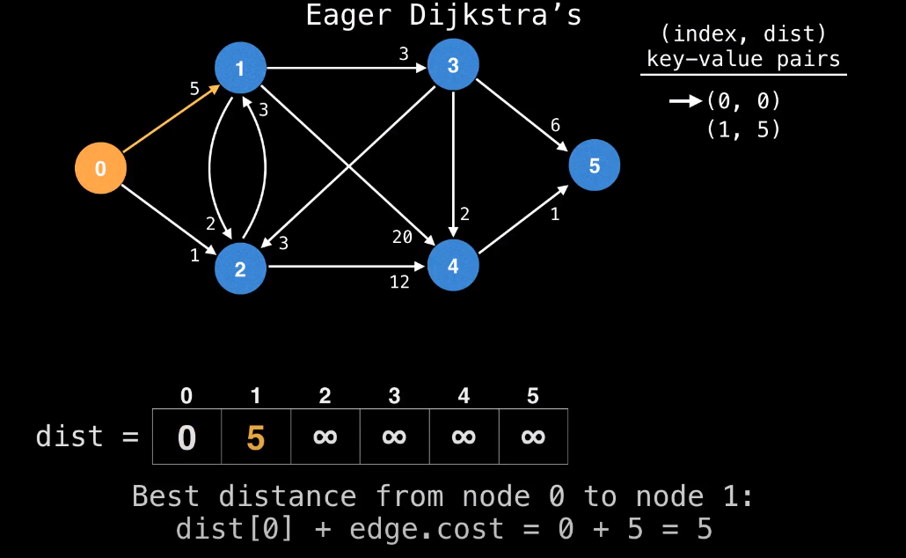

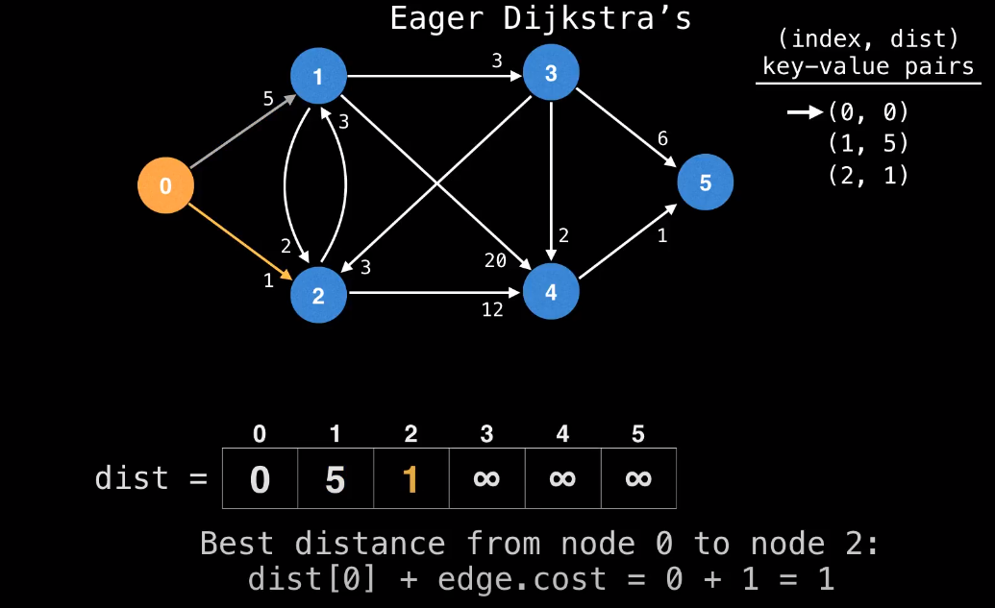

**We then pull the best key-value pair, so here 2, cause it has a dist of 1 compared to 5.**

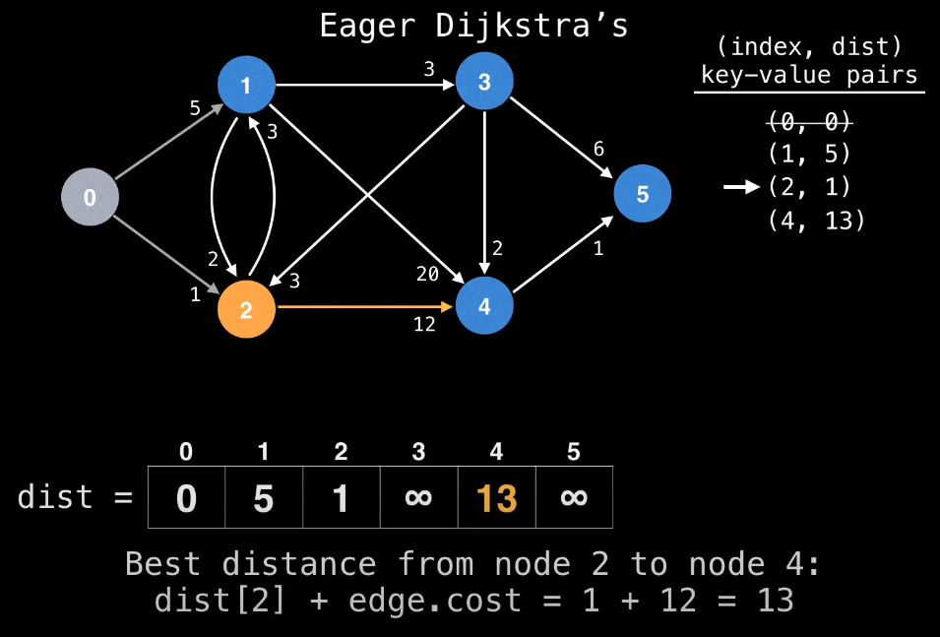

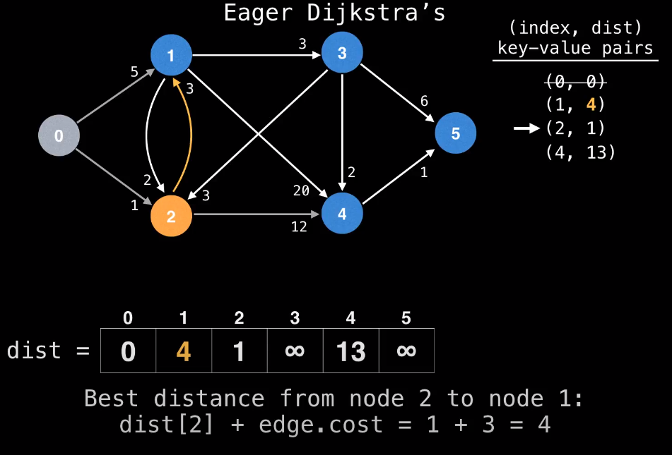

**We don’t insert a new key-value pair, we just update the pair, that already exists.**

**Afterwards node 1 is visited as it has the best key-value pair.** 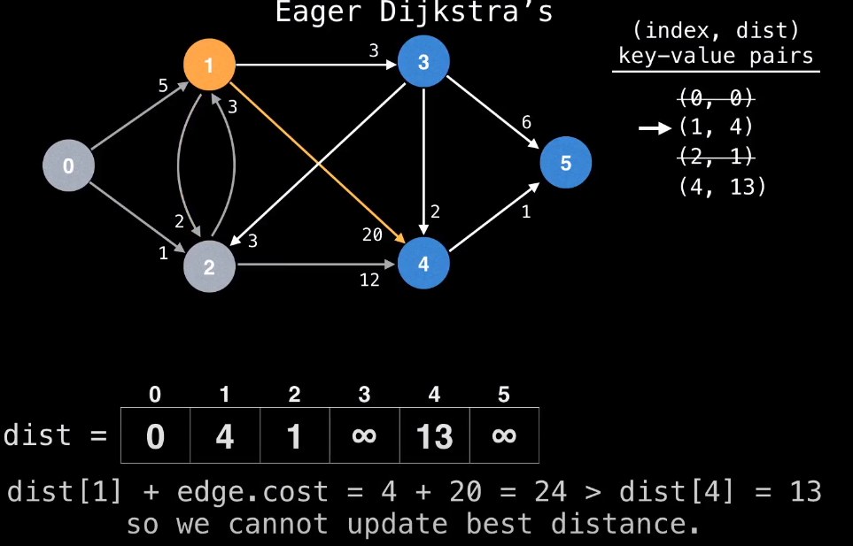

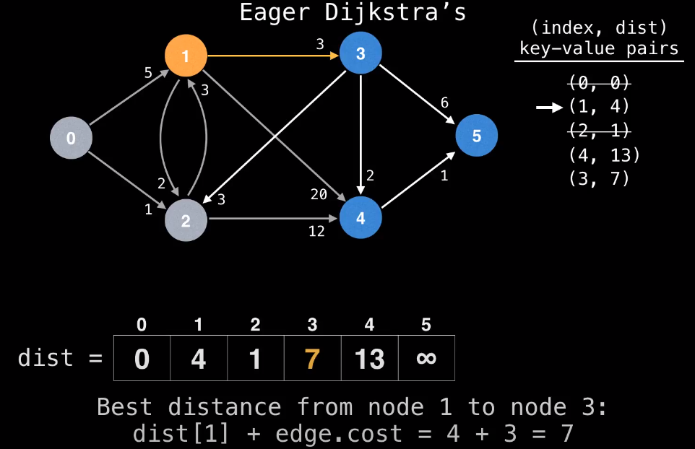

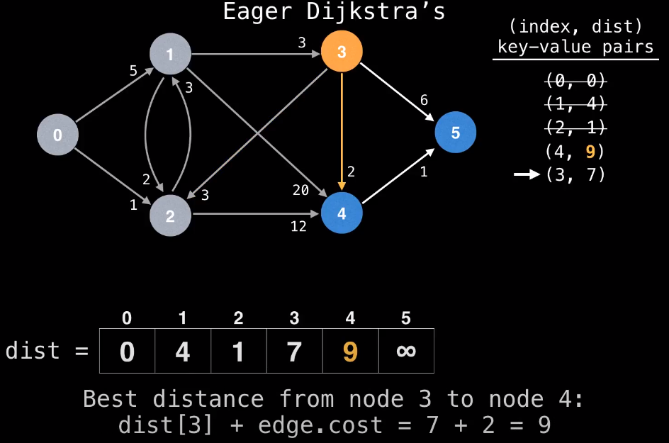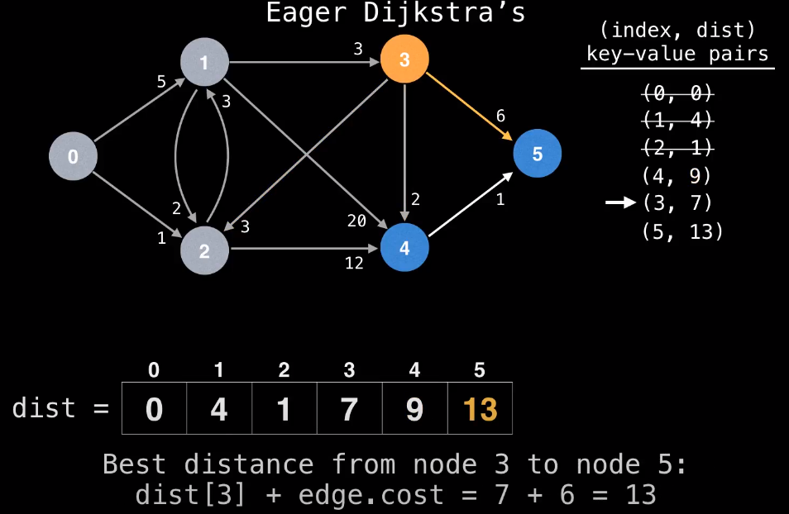

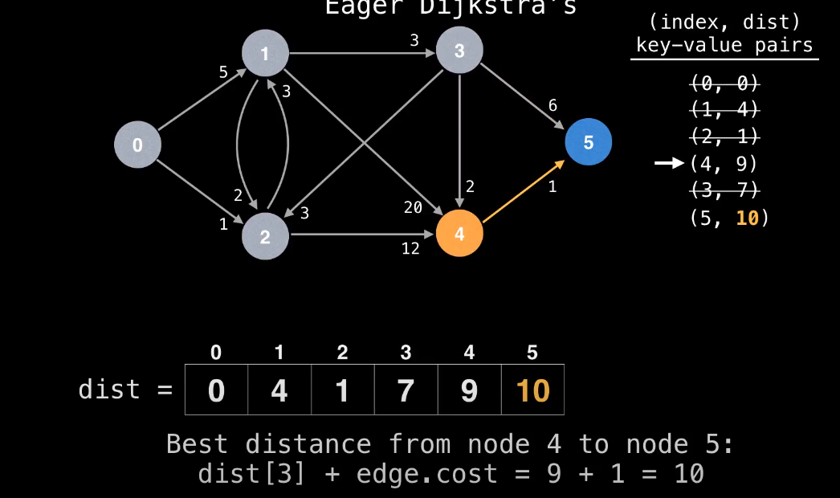

### Floyd-Warshall algorithm

is for solving the All Pairs Shortest Path problem. The problem is to find shortest distances between every pair of vertices in a given edge weighted directed Graph.

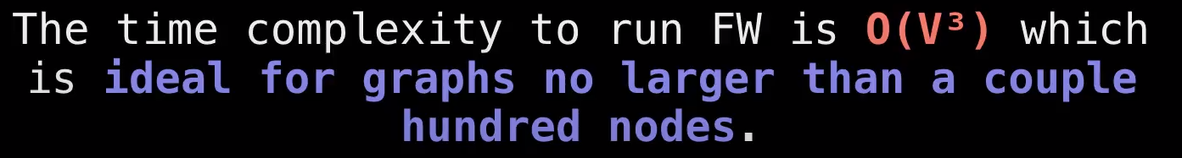

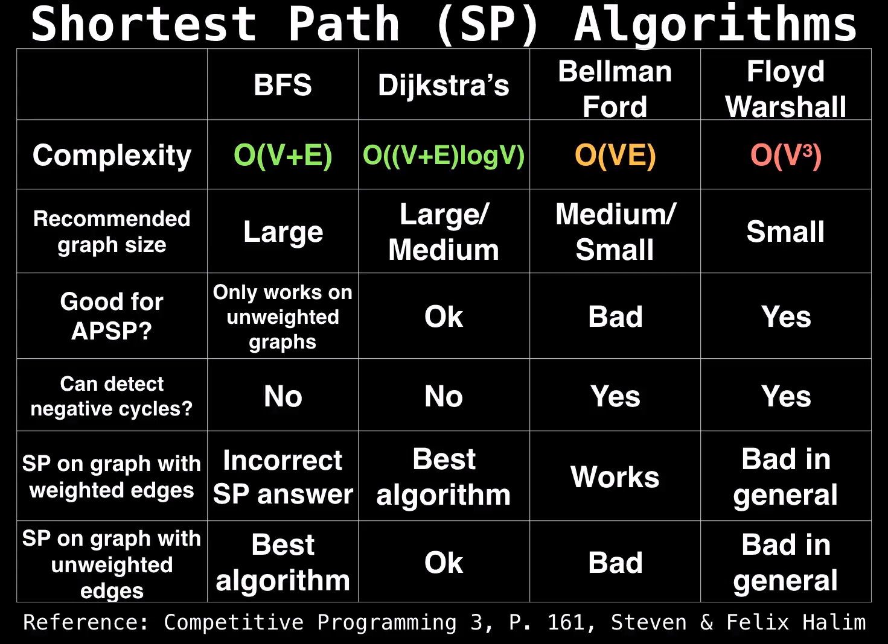

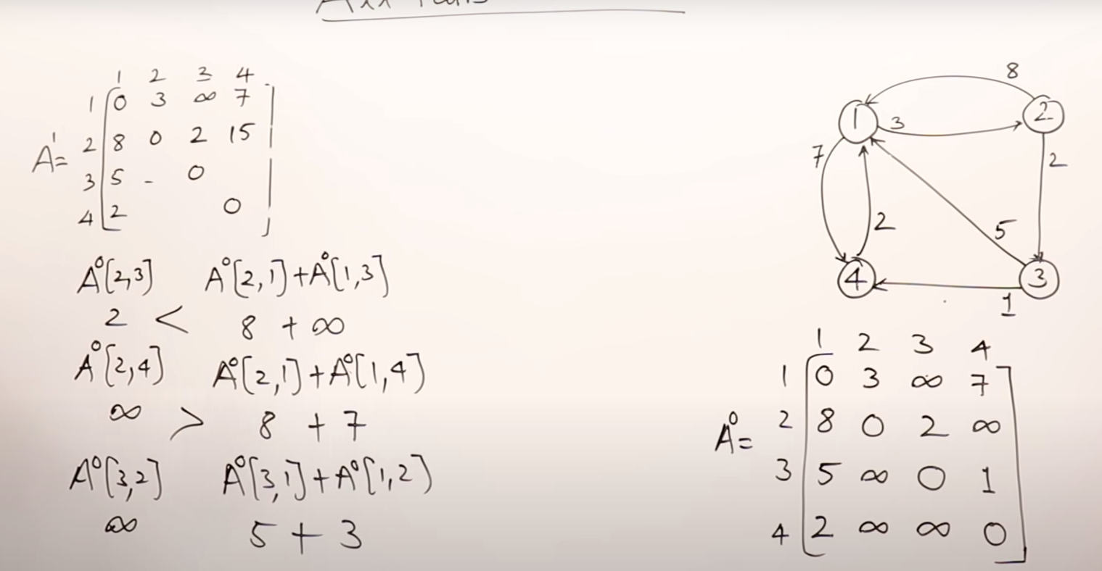

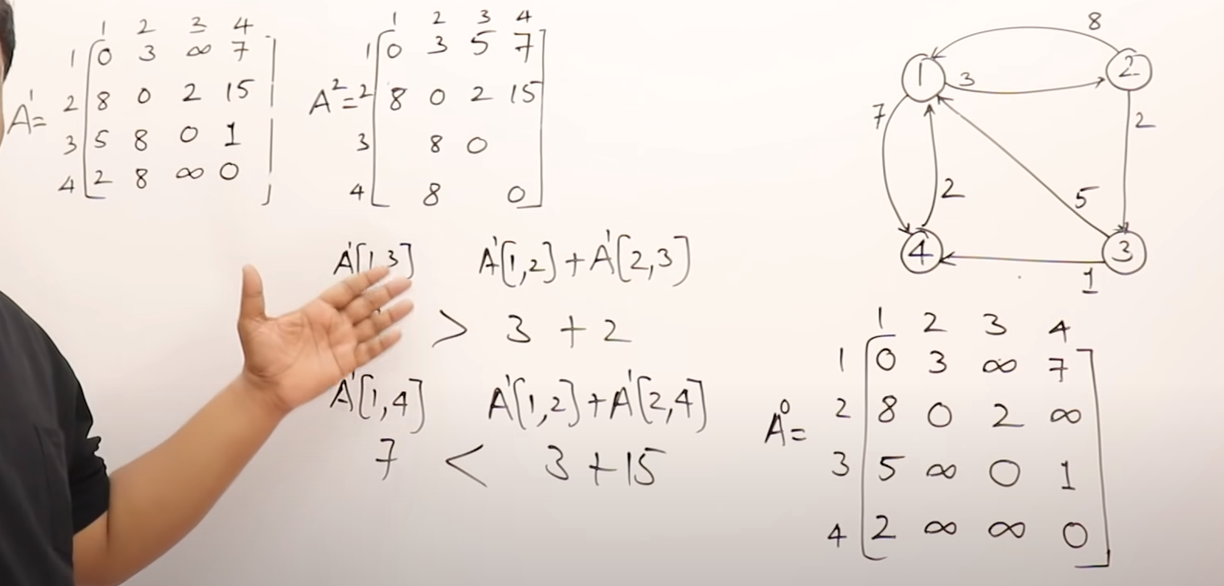

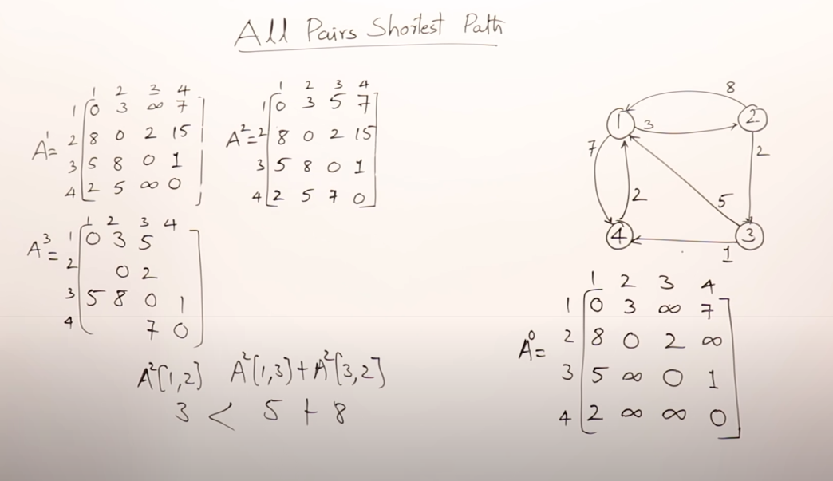

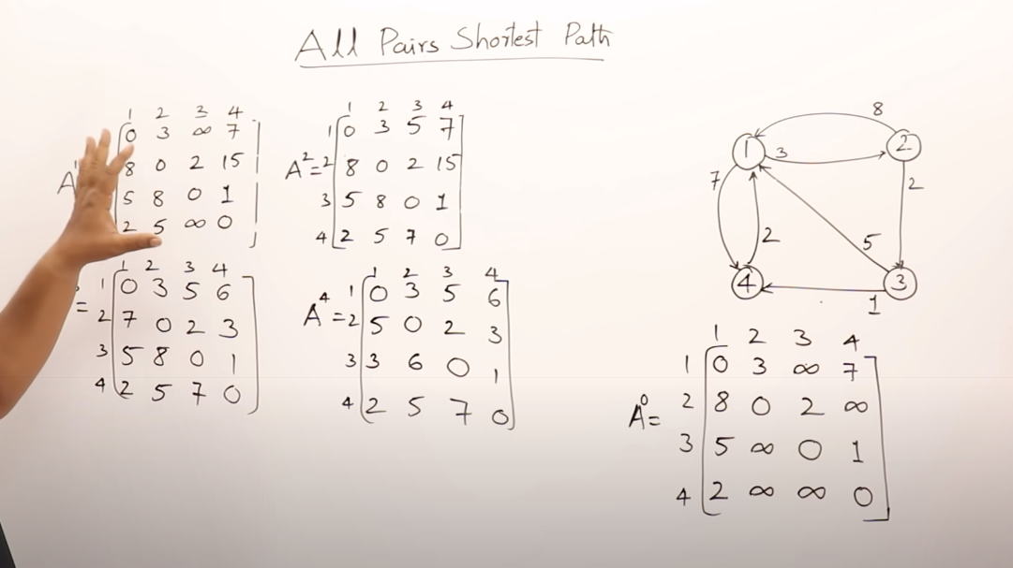

Måden det sker på er at du starter med A0, går slavisk igennem matricen, og indsætter værdier, derefter benytter du det nye matrice til at finde de næste værdier osv. Ved formlen   
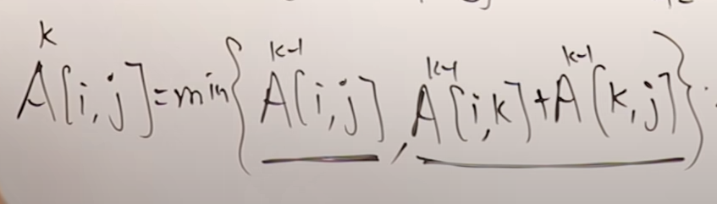

### Transitive closure of a directed graph

Given a directed graph, find out if a vertex j is reachable from another vertex i for all vertex pairs (i, j) in the given graph. Here reachable mean that there is a path from vertex i to j. The reach-ability matrix is called transitive closure of a graph.  
A vertex I can always reach itself.

**Reachability Matrix**

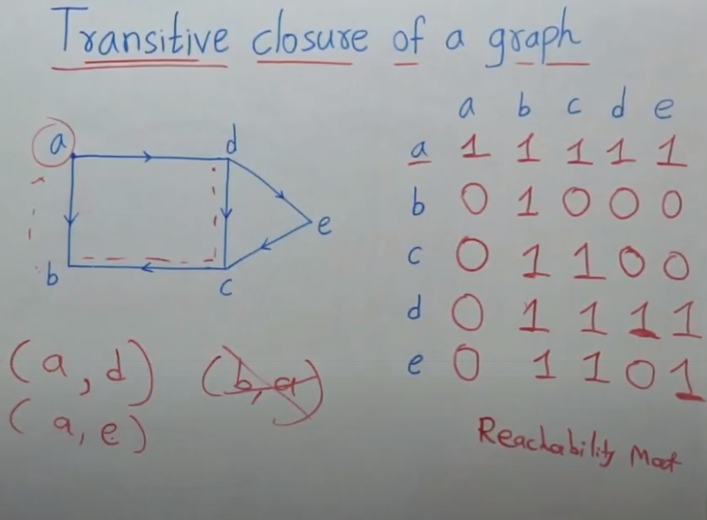

## Data Structures

### Max-Heaps & Min-Heaps

### Stacks

### Queues

### Linked Lists (both doubly-linked and singly-linked)

### Rooted Trees

### Hash Tables (direct-address, open addressing)

### Binary Search Trees

### Red-Black Trees

### Directed and Undirected Graphs (adjacency-list & adjacency-matrix representations)

### Weighted Graphs (adjacency-list & adjacency-matrix representations)

Every edge in a graph G = (V, E) has a weight property. This can be for both directed and undirected graphs.

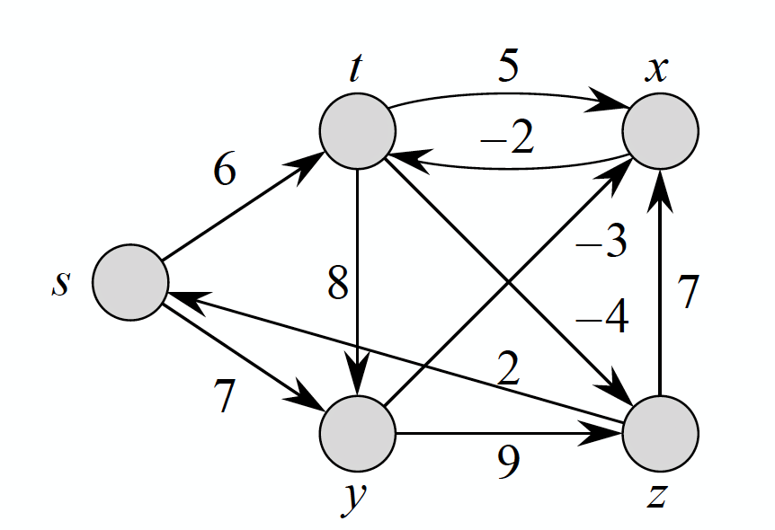

The total weight(*w*) of a path from start to destination is all the edges traveled in the parth(*p*) summed together.

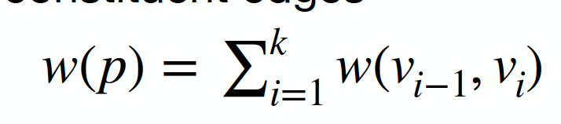

#### Definition of shorts paths

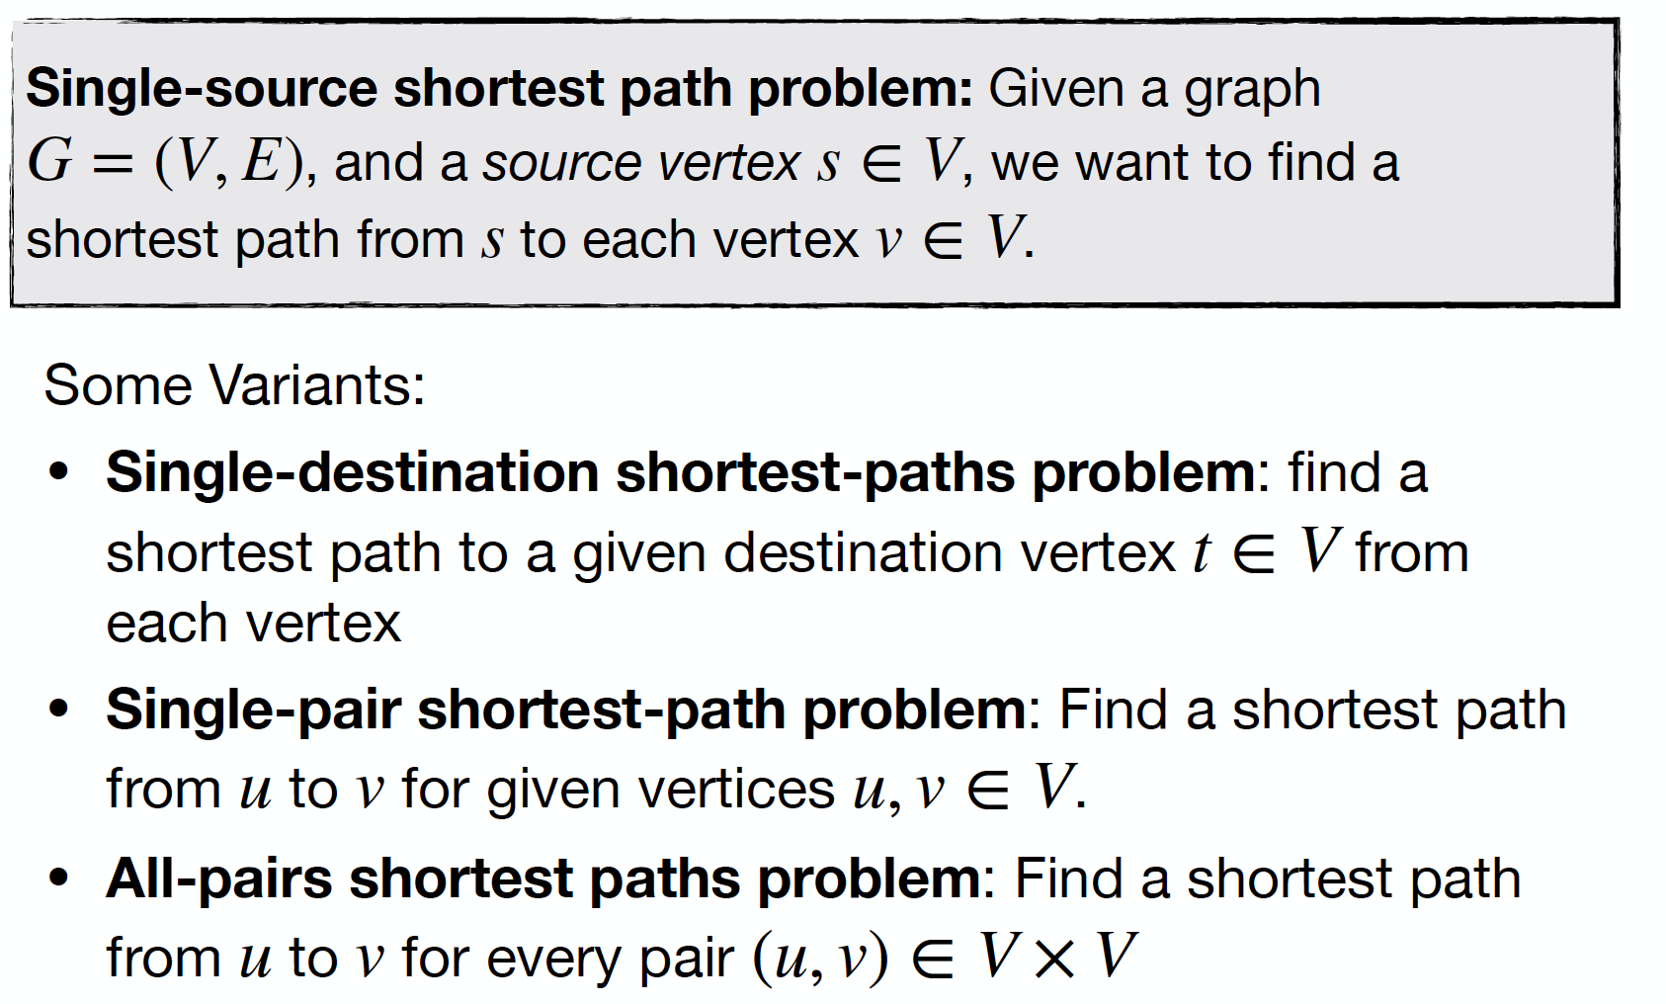

#### Cycles

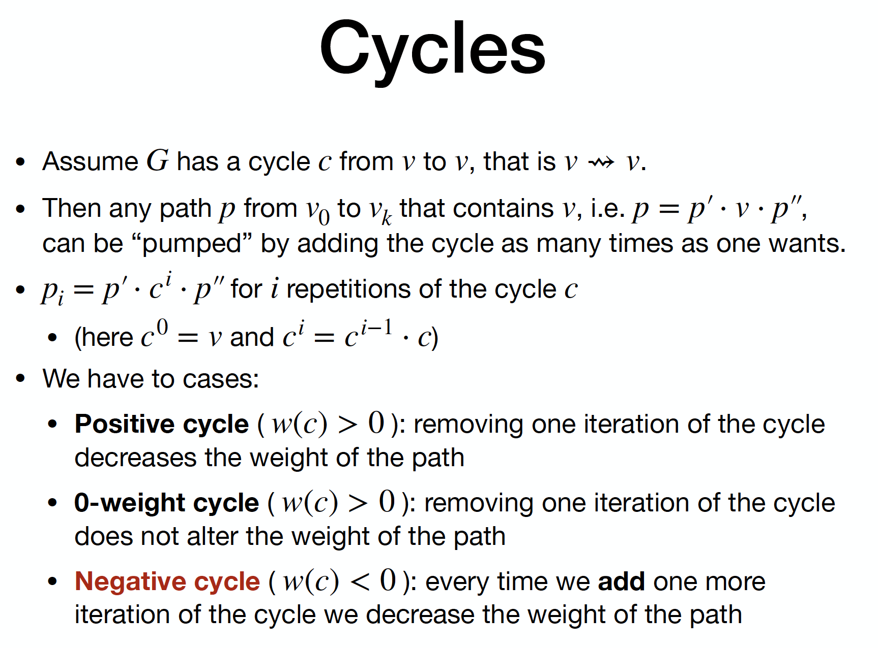

#### Relaxation

For every vertex *V* there is a property called *V.D* representing the shortest path estimate from the start vertex *S* to *V*. Before the algorithm is run to find the shortest path, there is an initialization of the graph with the following function:

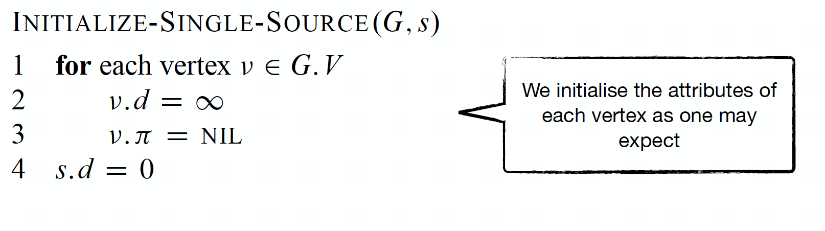

Afterwards the relaxation graph is run to improve the shortest-path estimates:

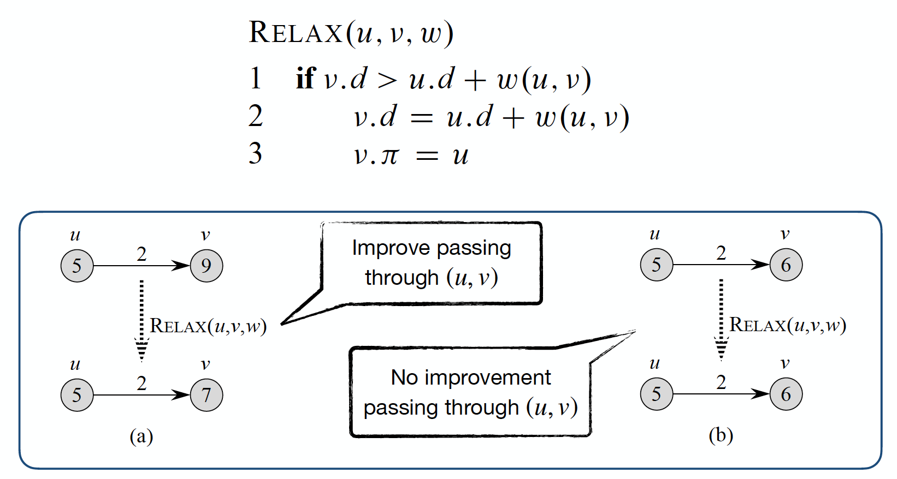

After the relaxation the following properties holds true:

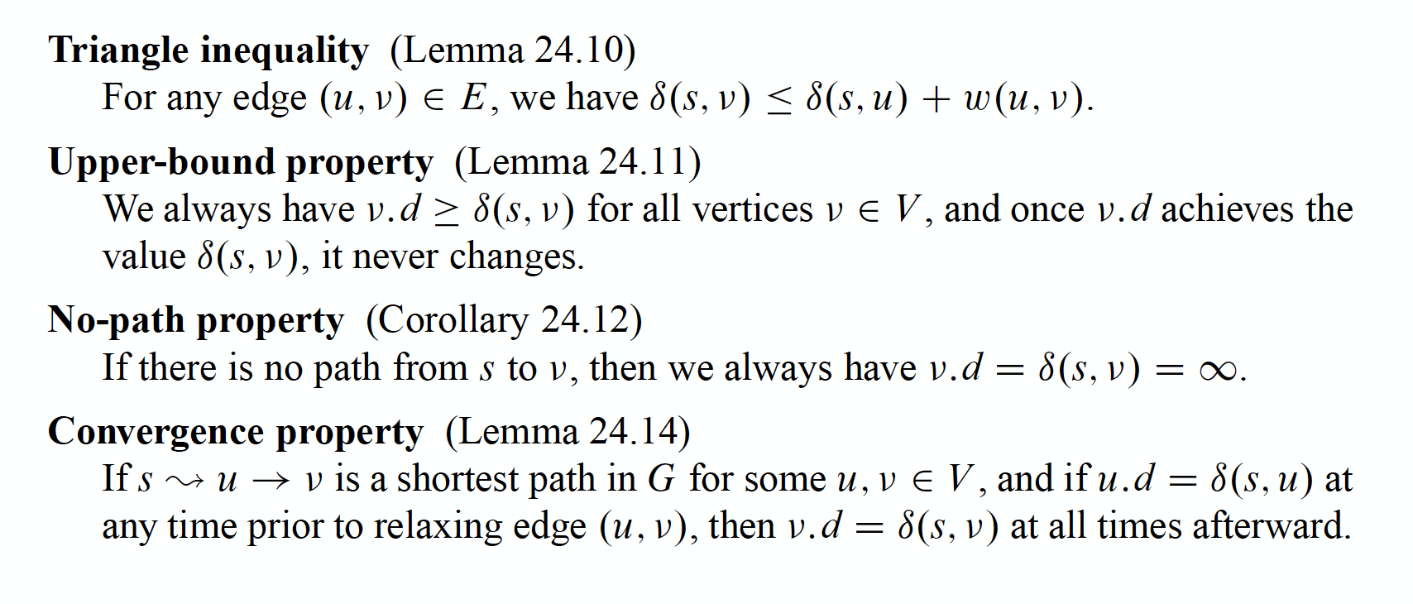

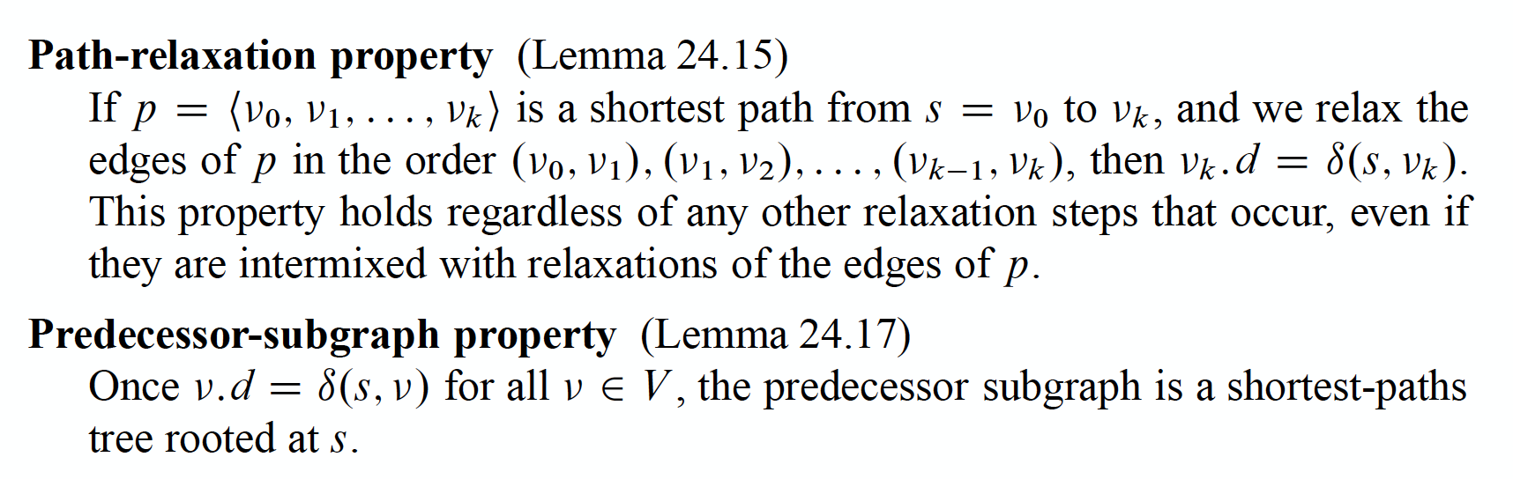

## Algorithm Design

### Divide and Conquer

### Dynamic Programming